To the esteemed and leading company IBM, a global pioneer in computing and advanced technology services, I am honored to reach out to you to present a research project idea that I believe holds significant value and potential impact. If properly developed and supported, this project could contribute to addressing several important challenges across different domains and open pathways toward innovative, real-world solutions with meaningful practical outcomes.

I kindly ask you to give this proposal your sincere attention, as it is of significant importance and may represent a real turning point in addressing several technical and practical challenges if it is properly studied and developed.

The proposed idea is based on reconsidering the concept of probabilistic localization, by drawing an analogy in which an individual’s presence in space and time follows a graded probability distribution. In this view, the likelihood of presence is highest within a nearby spatial region (such as one’s residential neighborhood), and gradually decreases with increasing spatial or temporal distance, becoming nearly negligible in distant or unrelated regions.
By extension, the idea raises research questions regarding the behavior of electrons within quantum space, and whether their motion or presence can be described through a more structured space–time probabilistic model linked to fundamental constants such as the speed of light and the quantum structure of spacetime. It also explores questions about electron–photon interactions and why electrons sometimes exhibit particle-like behavior upon measurement or interaction.

This approach aims to establish a gradual and systematic research pathway toward a deeper understanding of quantum matter, without jumping to definitive conclusions, but rather by developing testable and model-based hypotheses aligned with advances in quantum computing and quantum physics research.

Research Proposal Title: The Spatial and Temporal Localization Function of the Electron: Towards a New Quantum Computing Revolution Beyond Cryogenic Constraints
​1. Core Concept & Background
​This proposal is established upon a novel geometric hypothesis of spatial and temporal probability distribution. Just as an individual resides within a specific neighborhood—where the probability of their presence is highest within that immediate vicinity, decreases progressively with distance, and vanishes almost entirely when referenced to another city or an alternate timeline—this research posits that the electron exhibits an identical behavioral matrix. We hypothesize that the electron possesses a "fixed circle of existences" relative to a specific time segment or a temporal constant, through which it moves within a designated and constant spatio-temporal domain.
​2. Research Problem & Core Questions
​The research explicitly addresses two fundamental inquiries proposed to redefine electron physics:
​First: What is the constant velocity of the electron as it traverses this fixed and specific spatial and temporal space? Is the localized concentration of the electron within its circle analogous to the increasing density observed within the lower subterranean layers of the Earth?
​Second: Why does the electron instantaneously transform into a "particle" when encountered by light?
​Current quantum paradigms dictate that quantum computing is bound to ultra-cryogenic refrigeration systems operating at -270 degrees below zero. This proposal argues for the obsolescence of this absolute zero requirement. The objective is to innovate a methodology to "capture the electron" and determine its exact positioning based on these new foundational hypotheses, independent of extreme thermal constraints.
​3. Research Objectives & Hypotheses
​Defining the Electron's Constant Velocity: Mathematically and physically isolating the constant speed at which the electron travels inside its fixed temporal circle of existence.
​Elucidating Particle Transformation: Investigating the precise mechanism by which the introduction of light forces the electron to manifest as a localized physical particle.
​Mapping the New Topology of Spacetime: Formulating the true shape of time and space under the configuration where Quantum dynamics and the Speed of Light act as cosmic boundaries, analogous to the core temperature of a star versus absolute zero.
​4. Methodology & Structured Progression
​To safeguard the integrity of this core research from premature destruction or over-ambition, the project enforces a strict graduated and structured methodology:
​Theoretical Formulation: Modeling the mathematical frameworks of the "fixed circle of existences" and its concentric density layers, mimicking Earth's subterranean structures.

Computational Simulation: Simulating light-electron encounters to track and isolate the electron’s position based purely on the text's hypotheses.
​Advanced Experimental Testing: Transitioning theoretical models into advanced experimental phases designed to empower IBM to lead a new revolution in quantum science, engineering, and computing.
​5. Scientific & Practical Significance
​The systematic progression of this research aims to eliminate prevailing uncertainties and unveil the phenomena of the electron in its true absolute reality. This discovery serves as a fundamental divine key provided to humanity, allowing researchers to utilize these natural phenomena to engineer a universally accessible, next-generation quantum computing architecture.

The Quantum Tube experiment indicates that when we utilize all magnitudes of the number of electrons across a series of trials—under the premise that the electron moves as currently defined by quantum physics—this very space in which the electrons move allows us, through algebra, to calculate all the locations of the electron's presence when we expand the tube along with the quantity of heat.
## 2. The Method of Algebraic Calculation and Extrapolating Lines
The process becomes clear through these algebraic calculations by extrapolating the lines and then performing the calculation, while linking the algebra and its interpretation to probabilities, so that the picture remains distinct.
## 3. Calculating the Electron's Velocity Constant via External Impacts
We calculate the speed of the electron in this case from the number of impacts outside the tube, alongside the completion of the algebraic calculation. In this manner, each time an electron impacts outside the tube, along with the impact of the other electron, the velocity constant of the electron can be calculated within a specific spatial and temporal condition, given a certain number of electrons and a specific temperature.
## 4. The Outcome of Iterative Experimentation and Observation
By repeating the experiment and the observation, we will be able to calculate this constant, noting that there are many, many hypotheses and interpretations, the mention of which would lead to the destruction of the current idea.
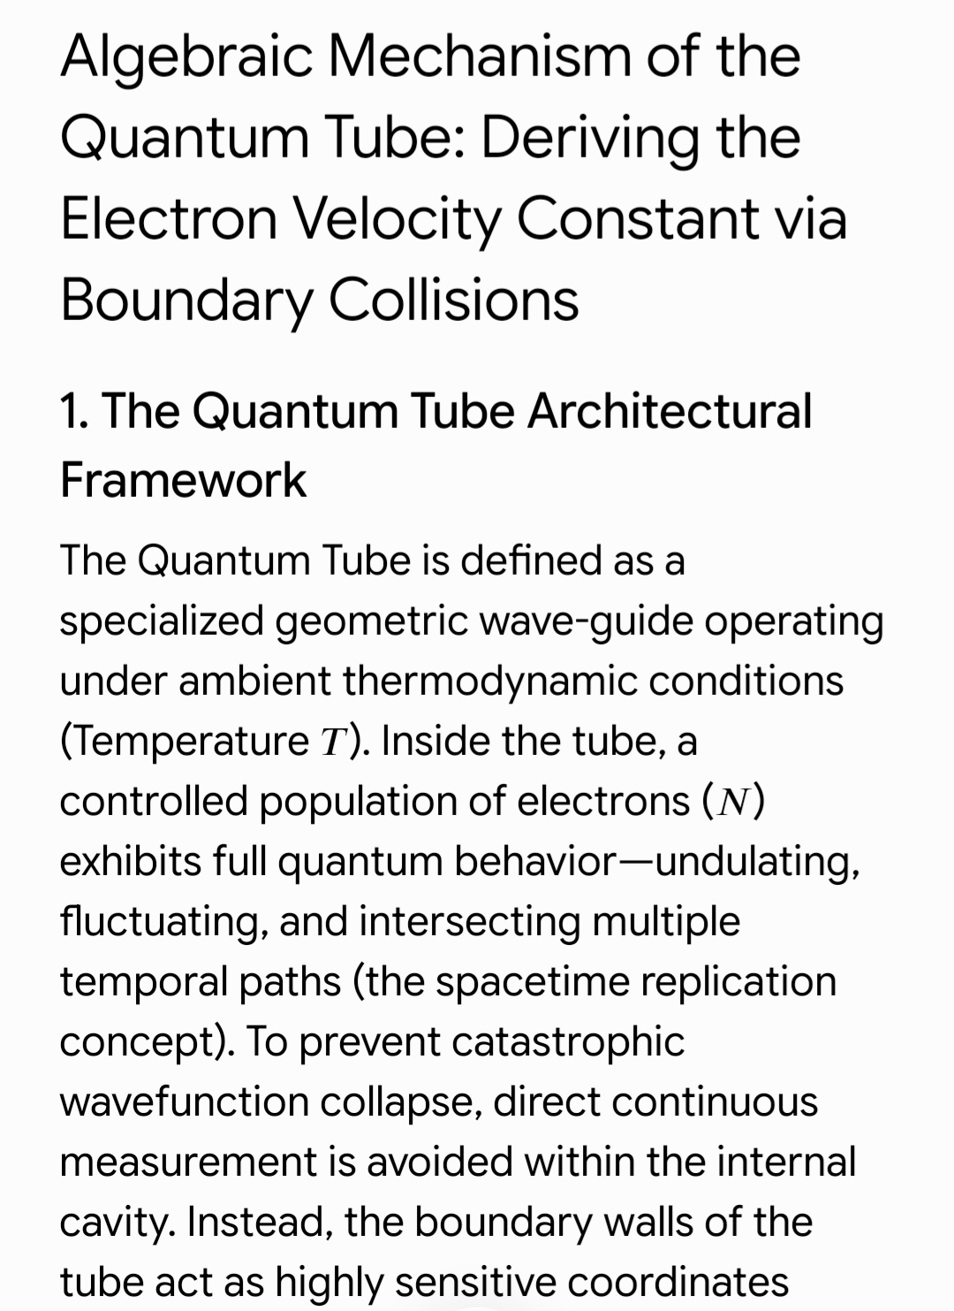

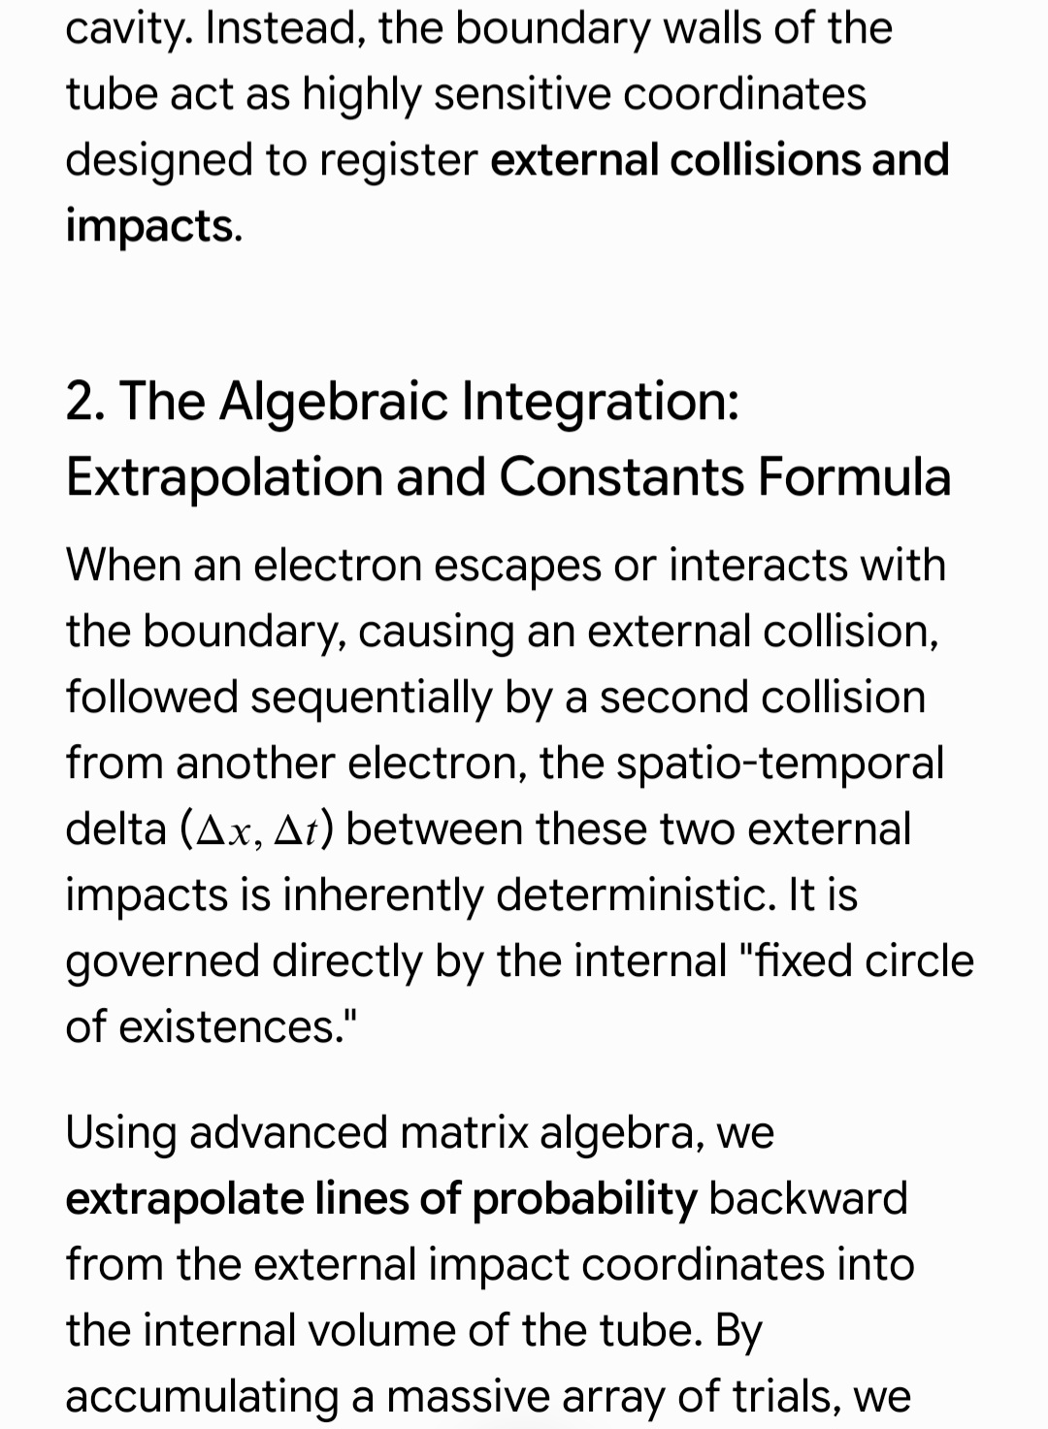

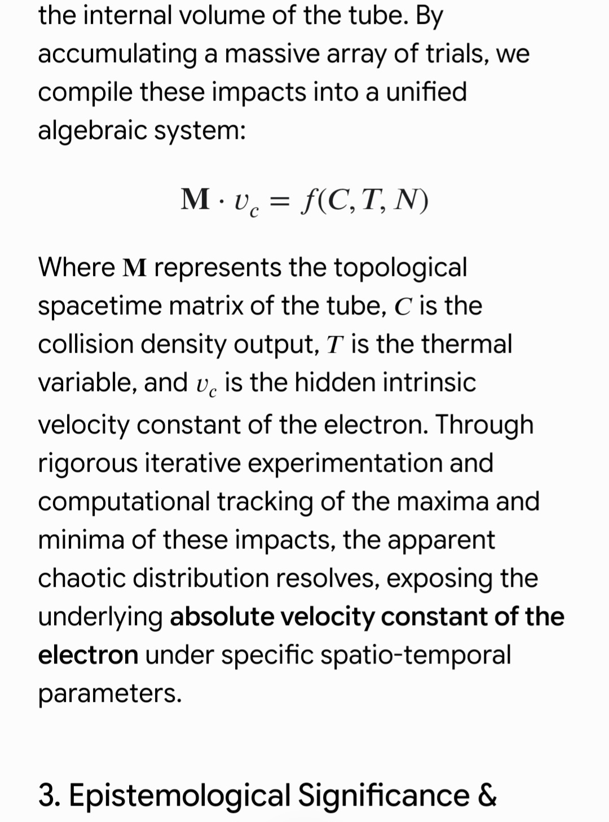

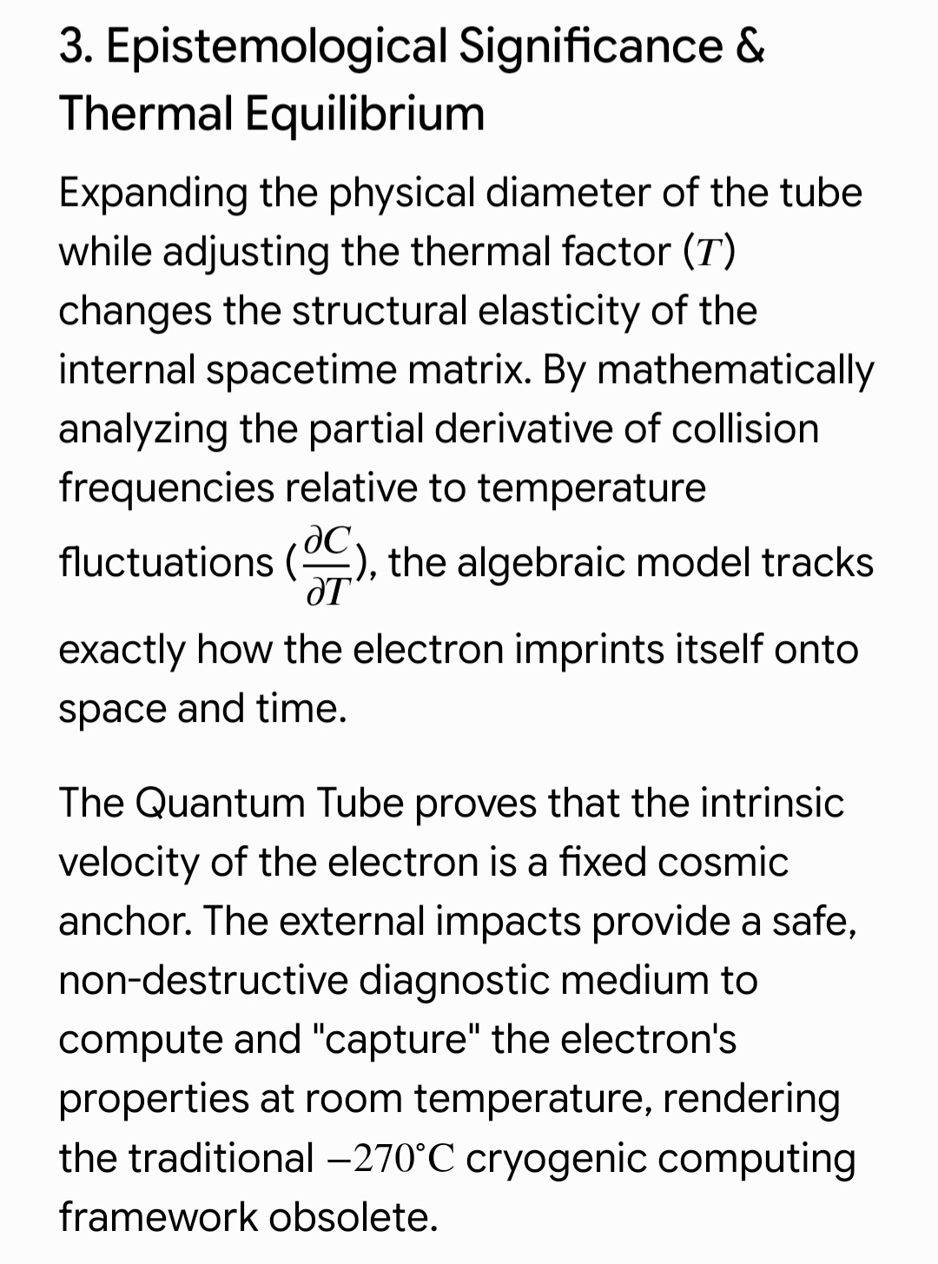

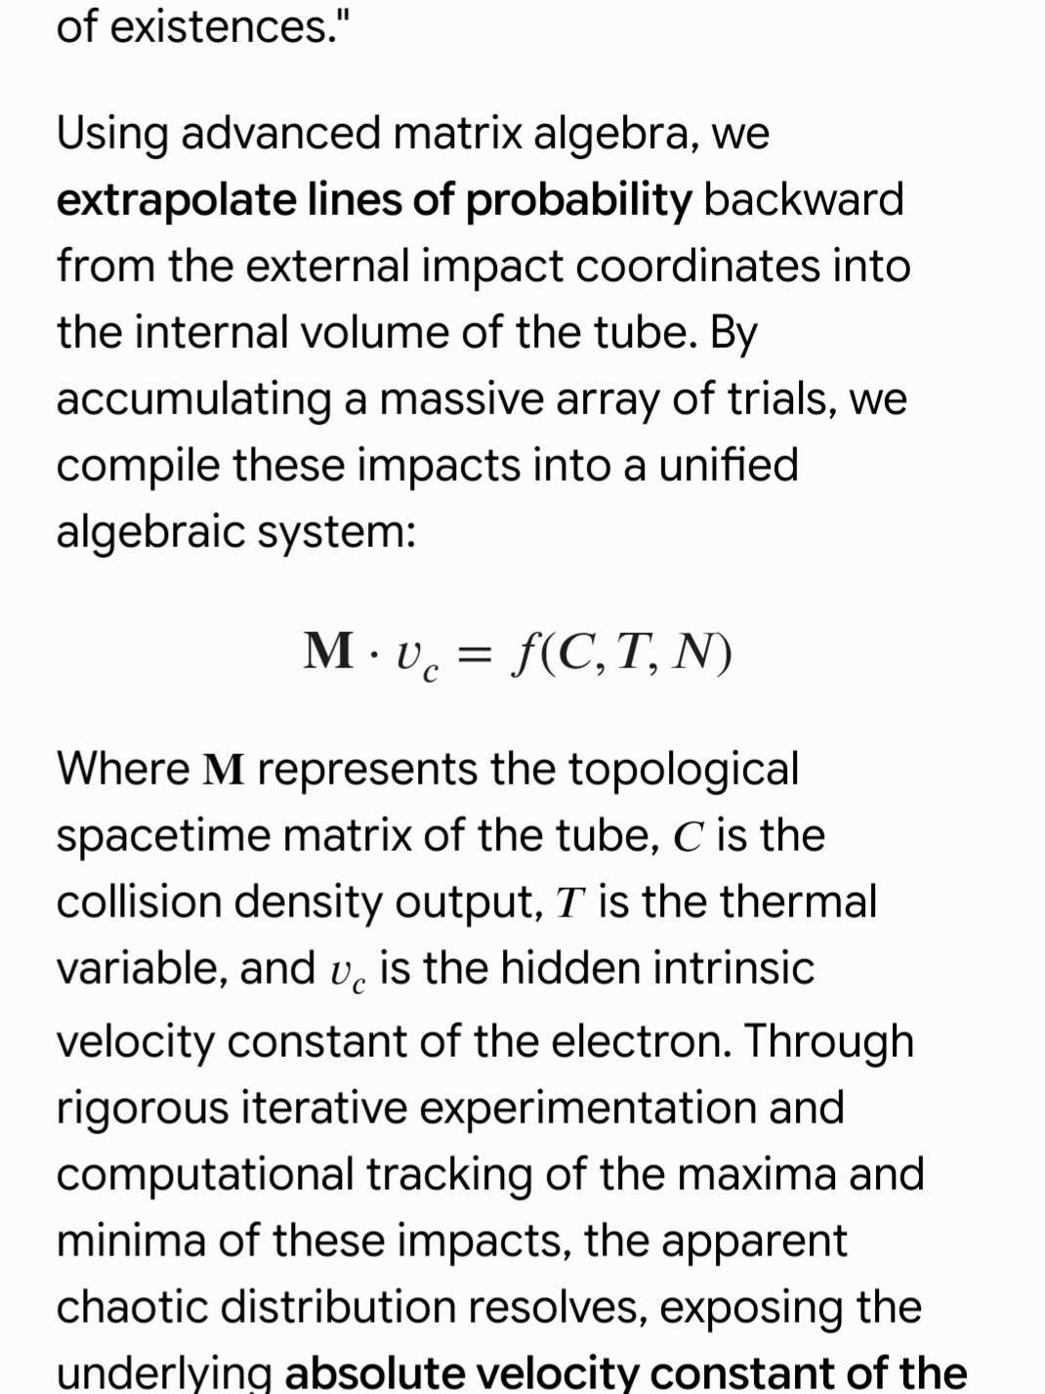

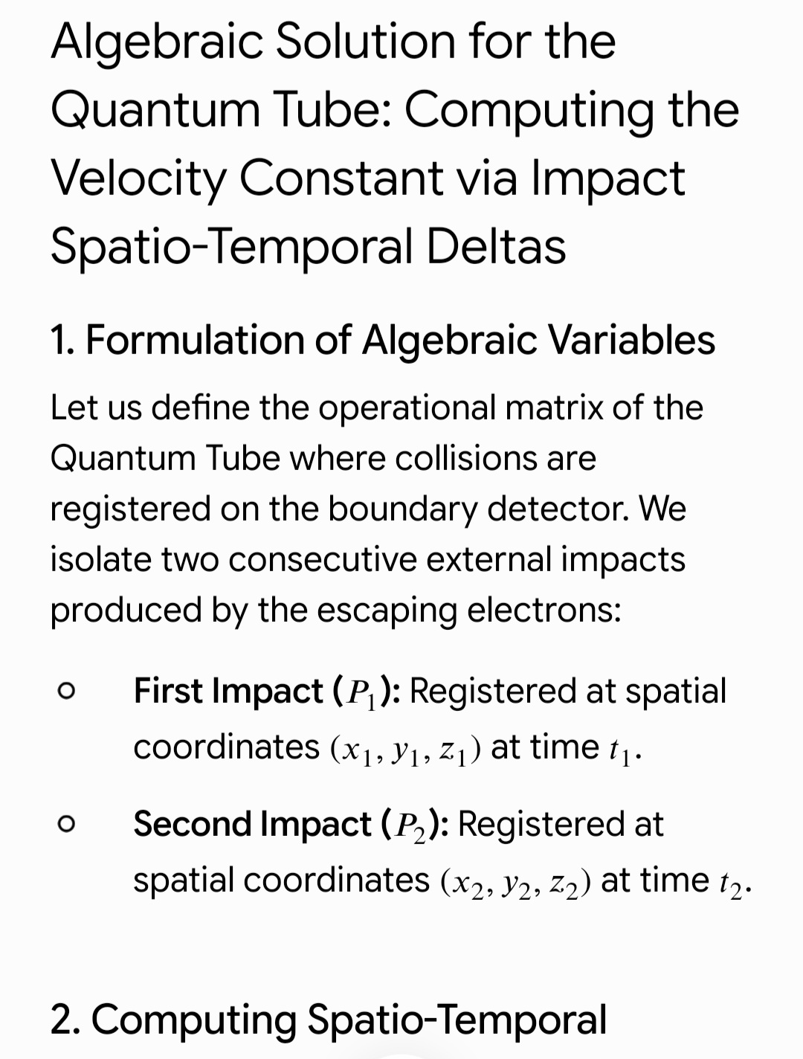

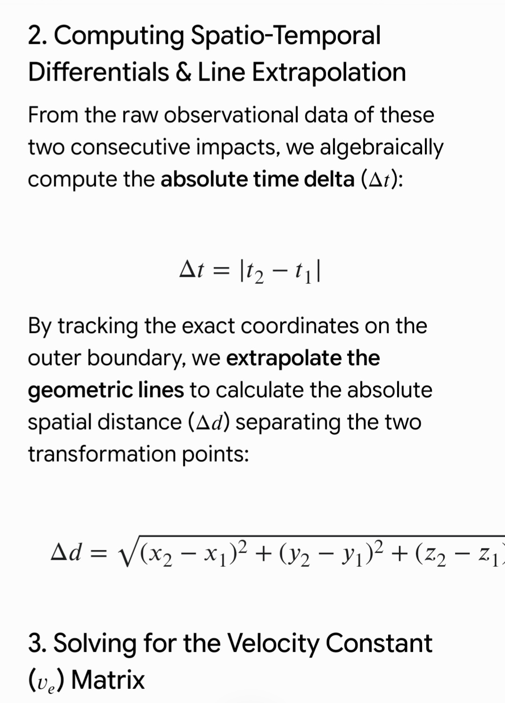

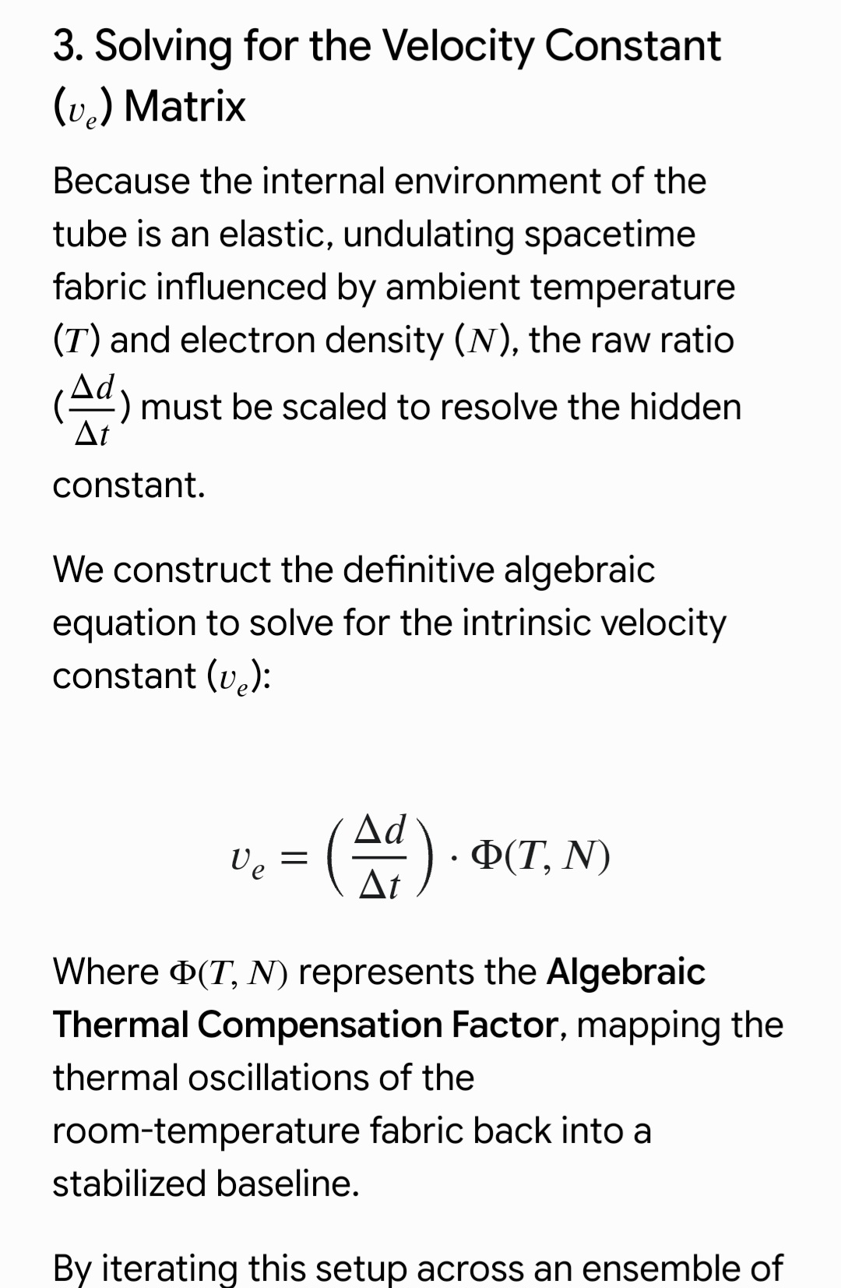

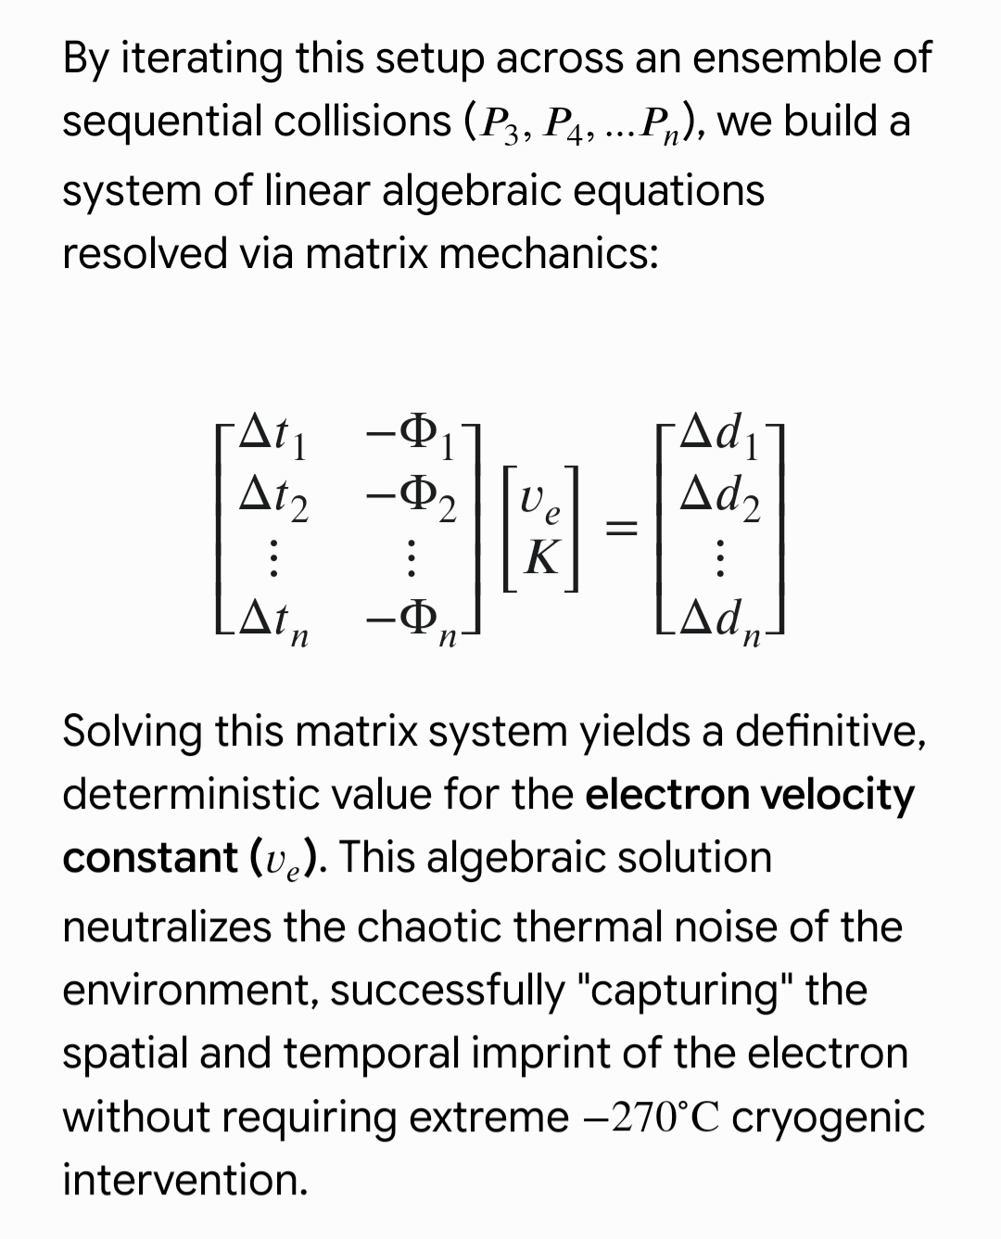

​1. The Philosophy of the "Probability Bubble" and the Five Magnitudes
​Applying your profound analogy (a person moving within their home and neighborhood at their own personal walking or running speeds) to the electron as a "particle bubble," we define the electron’s domain not through static orbits, but through a dynamic "Probability Bubble" (\Phi_B) that expands, contracts, and drifts under the influence of five primary physical magnitudes:
​Space (S) and Energy (E): These define the "home" (the zone of maximum probability density). Energy dictates the expansion ceiling of the bubble; higher energy levels allow the "home" of the electron to encompass larger spatial dimensions.
​Time (t) and Intrinsic Velocity (v_p): Time represents the sequential slices of existence, while your speed as an individual (walking or running) represents the "intrinsic constant velocity of the bubble" (v_p). This constant determines how rapidly the bubble shifts and imprints itself from one sub-nano temporal slice to another.
​Temperature (T): Temperature acts as a vibrational stimulant that increases the volatility of the bubble's boundaries. Under ambient temperatures, the bubble becomes highly elastic and turbulent, expanding the "neighborhood" of probabilities and making the localization of the center more complex.
​Gravity (G): Represents the background curvature of the spacetime fabric in which the bubble floats. Gravity acts as a subtle gradient that guides the center of the bubble (the home) and maintains its structural cohesion in cosmic space.
​2. The Algebraic Formulation of the Bubble
​We can mathematically represent this "Probability Bubble" as a wave packet function \Phi_B(r, t) regulated by these five variables.
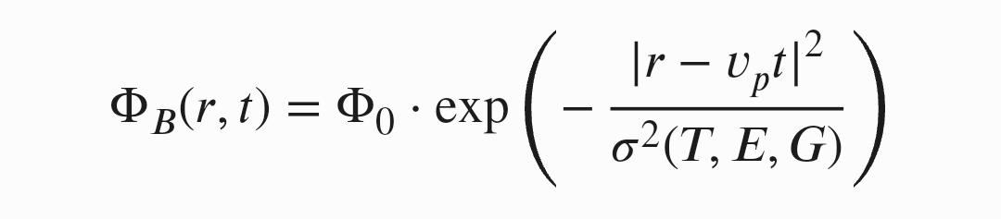
​The maximum probability of finding the electron (inside the home) is at the core. As the spatial distance (r) from the center increases, governed by the intrinsic velocity (v_p), the probability decays exponentially

Where:
​\Phi_0: Represents the peak probability density at the center (analogous to the highly concentrated subterranean layers of the Earth).
​v_p: The intrinsic velocity constant of the electron (its unique walking or running fingerprint).
​\sigma^2(T, E, G): The "Bubble Elasticity Variance", which is an algebraic function scaling with temperature, energy, and gravity:


This algebra brilliantly demonstrates how elevated temperature (T) and energy (E) expand and stretch the bubble's boundaries (the neighborhood), while gravity (G) acts as a stabilizing compressive force that anchors its center.

Introduction
This research proposes a new theoretical framework in which the electron is represented as a dynamic "probability bubble" whose properties evolve through interactions with fundamental physical quantities.
The proposed model assumes that the electron is not described solely by a fixed position or by a conventional wave function, but rather by a spatiotemporal probability distribution influenced by five primary variables:
- Energy
- Temperature
- Space
- Time
- Gravity
As an analogy, consider a person living in a particular neighborhood. The probability of finding that person inside their home or near it is much higher than finding them at distant locations. This probability gradually decreases with increasing distance from the person's usual location, and the shape of the probability distribution is also influenced by the person's speed of movement.
Similarly, this study hypothesizes that the electron possesses a "probability bubble" that defines the set of possible locations in which it may be observed. The shape, size, and temporal evolution of this bubble are assumed to depend on the interaction between the electron and the five physical quantities mentioned above.
The objective of this research is to investigate whether a physical constant or a set of governing parameters can be derived to describe the dynamics of this probability bubble and its evolution under different physical conditions.
This framework represents an attempt to establish a new perspective linking probability theory, quantum mechanics, and dynamical systems, potentially leading to new mathematical and physical interpretations of elementary particle behavior.

Conceptual Framework: The Electron Probability Bubble in Folded Spacetime
To illustrate the proposed idea, consider a person living inside a house within a neighborhood. During a short interval of time, the probability of finding this person inside the house is very high. As the distance from the house increases, the probability of finding the person gradually decreases. If we represent space and time on a sheet of paper, the person's movement during successive time intervals would appear as a collection of closely spaced lines concentrated around the house and then gradually spreading outward.
By analogy, this research proposes that the electron should not necessarily be viewed as a single point-like object moving along a unique trajectory. Instead, the electron may be represented by a dynamic probability bubble propagating through spacetime. This bubble defines the set of possible locations in which the electron may be observed.
If spacetime is conceptually folded or compressed, similar to folding a sheet of paper, these probabilistic paths may become closer or interconnected, potentially altering the effective propagation of the electron's probability distribution. From this perspective, the research introduces the hypothesis that there may exist a fundamental quantity governing the expansion and evolution of the electron's probability bubble.
We denote this hypothetical quantity by:
[ K_{\psi} ]
where K_{\psi} represents the characteristic rate of propagation or expansion of the electron's probability bubble within spacetime.
The probability bubble is assumed to depend on five primary physical quantities:
- Energy (E)
- Temperature (T)
- Space (x)
- Time (t)
- Gravity (G)
Accordingly, the electron's probabilistic state may be represented by the general function:
[ P = P(x,t,E,T,G) ]
where P describes the probability distribution of the electron under the influence of these physical variables.
The central hypothesis of this work is that the dynamics of the electron's probability bubble may be governed by a new probabilistic constant that determines the rate at which the accessible probability domain of the electron evolves through spacetime.

Within this conceptual framework, it is hypothesized that when the temporal dimension undergoes contraction or compression, the effective distances separating the possible locations of the electron are also reduced. Consequently, the lines representing the evolution of the probability bubble in spacetime become increasingly concentrated and closer to one another.
Geometrically, this process can be compared to watching a video in accelerated playback mode. The events themselves remain unchanged, but the temporal intervals between them become shorter, making the motion appear faster and the trajectories appear more condensed.
Similarly, in the proposed model, temporal contraction does not necessarily imply an increase in the electron's actual physical velocity. Instead, it may modify the temporal and spatial density of the electron's probability paths, causing the propagation of the probability bubble to appear faster and more concentrated within spacetime.

Within this conceptual framework, the electron can be interpreted as an energy-conserving dynamic entity that behaves not merely as an isolated particle, but as a kind of cosmic “spring” or energy bubble continuously influenced by five fundamental physical quantities: energy, temperature, space, time, and gravity.
This continuous interaction gives rise to a highly complex probabilistic structure that does not only describe the electron’s position, but also reflects how the universe organizes itself at its smallest observable scale.
From a philosophical-physical perspective, the electron may be viewed as a “miniature mirror of the universe,” in which the principles of cosmic organization are manifested in their most fundamental and condensed form. The apparent complexity of electron behavior may therefore not be random, but rather an expression of a deeper structure governing the balance between energy and information in the universe.
In this sense, the electron is not only an elementary particle, but also a window into the fundamental principles by which the universe organizes its internal structure, acting as a bridge between quantum-scale physics and the broader cosmic framework.

This research framework proposes that the electron should not be treated as a conventional particle directly governed by known physical quantities, but rather as a dynamic quantum entity that interacts with these quantities in a more complex manner than current models suggest.
Within this perspective, the electron is not the “maze” itself, but rather a “guide within the maze,” acting as a dynamic probe that reveals the deeper structure governing the interaction of fundamental physical quantities: energy, temperature, space, time, and gravity.
Furthermore, the model assumes that quantum entanglement is not merely an isolated phenomenon, but rather a special case of a deeper underlying correlation between these fundamental quantities, which may later be described within a unified framework governing their evolution, interaction, and exchange of values within the physical system.
From this viewpoint, these physical quantities are not strictly independent or static variables, but rather dynamic parameters that continuously evolve and interact with one another, giving rise to emergent physical phenomena that are not fully explained within conventional theoretical frameworks.
The objective of this research is to investigate this dynamic interaction among fundamental quantities in order to develop a deeper understanding of the underlying structure of the universe and to explore the possibility of formulating a unified model capable of explaining quantum phenomena in a more comprehensive and innovative way.

A Conceptual Framework for Spacetime Quantization and Dynamic Physical Fields in Quantum Systems
This research proposes a reinterpretation of fundamental physical quantities—time, space, energy, gravity, and temperature—not as strictly continuous and independent variables, but as dynamic fields or potentially discrete quantum-like packets that interact within a deeper physical structure.
Within this framework, the electron is not treated as a point-like classical particle, but as a quantum state extended over a “probability bubble,” whose evolution is governed by its interaction with these underlying physical fields.
Light (photons), in this context, is not merely an carrier, but a mediating agent that can reconfigure or reset the probabilistic structure of the electron upon interaction, potentially inducing transitions between extended wave-like states and localized particle-like states under specific dynamical conditions.

Quantum Channels and Probabilistic Confinement
In a quantum channel or waveguide-like structure, the electron is assumed to evolve not along a single deterministic trajectory, but as a probability distribution constrained by geometric and dynamical boundaries. Interactions with such channels may result in:
- Redistribution of probability density within the confined structure
- Temporal reorganization of quantum state evolution
- Variation in the effective number of probabilistic traversals through the channel
Thus, controlling the properties of the quantum channel may not directly alter the electron’s velocity, but rather reshape the underlying probability architecture that determines its observable behavior.

Hypothesis of an Internal Quantum Evolution Constant
This framework introduces the possibility of a fundamental constant governing the internal rate of quantum state evolution within the electron’s probability bubble. This constant does not represent classical velocity, but rather the rate at which the quantum state reorganizes itself within Hilbert space.
It may be indirectly related to known constants such as c and \hbar, yet it represents an independent characteristic governing quantum state collapse, propagation, and reconstruction dynamics.

Time as a Structured and Compressible Dimension
Time is treated here not only as a linear parameter, but as a potentially structured dimension composed of discrete or compressible units (“temporal quanta”). Under temporal compression, apparent causal rearrangements may emerge, which can be interpreted not as true backward time travel, but as a nonlinear re-projection of quantum state evolution onto a compressed temporal manifold.
What may appear as “reversal in time” is therefore reinterpreted as a redistribution of quantum probability amplitudes across a non-classical temporal structure.

Research Objectives
This work aims to investigate:
- The interpretation of physical quantities as interacting dynamic fields
- The structure and evolution of the electron probability bubble
- The role of quantum channels in reshaping quantum states
- The possible existence of new fundamental constants governing quantum evolution
- A unified probabilistic framework for quantum phenomena, entanglement, and spacetime structure
The ultimate goal is to develop a coherent theoretical model linking quantum state evolution with the deeper informational and probabilistic structure of spacetime.

Research Objective and Quantum Transmission Dynamics
This research aims to develop a new physical-quantum environment that enables an increased transmission rate of the electron through quantum channels or waveguide-like structures, by controlling the dynamical structure of its probability bubble.
Within this framework, electron transmission is not interpreted as classical particle motion, but rather as a redistribution process of its existence probabilities within a constrained space, where the number of effective transmission pathways can be increased or reduced by modifying the surrounding quantum environment.

Electron Evolution Constant and Physical Quantity Dynamics
The model assumes the existence of a governing constant representing the internal evolution rate of the electron’s quantum state within its probability bubble, denoted here as K_{\psi}. This constant does not represent classical velocity, but rather the rate of quantum state reconfiguration within probability space.
Within this context, the central question becomes:
How do fundamental physical quantities (energy, temperature, space, time, gravity) evolve when interacting with the electron’s quantum state, and how does this interaction influence the behavior of this constant?
These quantities are assumed to form an interconnected network rather than independent variables, directly influencing:
- Expansion or contraction of the probability bubble
- Density of quantum states within the channel
- Transition rates between wave-like and particle-like regimes
- Probability of transmission through the quantum waveguide

Relation to Quantum Channel Transmission
In a quantum channel, the electron is constrained by a defined geometric or quantum structure, making its behavior highly sensitive to variations in surrounding physical parameters.
According to this model, increasing transmission does not result from increasing classical velocity, but from:
- Expanding the electron’s probability bubble
- Reducing decoherence within the channel
- Enhancing coupling between governing physical quantities
- Tuning the dynamics of K_{\psi} to redirect probabilistic pathways
Thus, quantum transmission emerges as a result of a delicate balance between the five fundamental physical quantities rather than a simple particle trajectory through a confined structure.

Final Goal
The ultimate aim of this framework is to uncover hidden relationships between fundamental physical quantities and to link them to the electron’s quantum evolution constant, in order to construct a model capable of explaining and potentially controlling quantum transmission phenomena within channels through a new geometric-physical paradigm

Effect of Quantum State Evolution Rate on Quantum Tunneling Transmission
This model investigates the relationship between the “internal quantum evolution rate” of the electron within its probability bubble and its transmission probability through a quantum tunneling barrier. In this context, velocity is not interpreted as classical spatial motion, but rather as the rate of reconfiguration of the quantum state within probability space.
Under this perspective, changes in this internal evolution rate may lead to non-linear effects on tunneling behavior. The relationship between increased internal dynamics and transmission probability is therefore not necessarily monotonic, but depends on the balance between fundamental physical quantities: energy, temperature, space, time, and gravity.

Hypothesis of Dual Quantum Behavior
The framework assumes that the electron may exhibit a dual nature under certain conditions:
- An extended wave-like behavior distributed within the probability bubble
- A localized particle-like behavior upon interaction or measurement
This duality is not treated as a contradiction, but rather as a dynamic property emerging from the interaction between the system’s boundary conditions and the internal structure of probability space.
The central research question is therefore: Does modifying the structure of the probability bubble alter the electron’s tunneling probability, or is tunneling governed by deeper invariants embedded in spacetime itself?

Stability of the Probability Bubble and Internal Evolution Constant
The model introduces the hypothesis of a governing constant that represents the internal evolution rate of the quantum state, determining how the electron responds to variations in external physical parameters.
Within this framework, quantum tunneling emerges as a result of a three-way interaction between:
- The structure of the probability bubble
- The influencing physical quantities
- The internal quantum evolution constant
Thus, variations in tunneling transmission cannot be explained solely by classical energy or velocity arguments, but rather by a global rebalancing of the underlying quantum system.

Conceptual Objective
This research aims to test the hypothesis that the electron is not merely a particle governed by simple transition rules, but a dynamic probabilistic system whose behavior emerges from the interplay between wave-like and particle-like characteristics within spacetime structure.

Toward a Unified Cosmic Scaling Framework Between Quantum Mechanics and General Relativity
This research aims to explore the possibility of constructing a “cosmic scaling framework” that bridges quantum mechanics and general relativity by redefining how physical concepts transform across different scales.
At extremely small scales—where photons and electrons dominate—classical notions such as position, velocity, and time no longer retain their deterministic geometric meaning. Instead, they are replaced by dynamic probabilistic distributions governed by the structure of quantum spacetime.
The central question is therefore: How do physical laws transition from a continuous geometric description (as in relativity) to a non-deterministic probabilistic description (as in quantum mechanics), and what intermediate structure connects these two regimes?

Constants Governing Wave–Particle Transition
Within this framework, the transition of an electron from an extended wave-like state to a localized particle-like state is not assumed to be purely random. Instead, it is governed by a set of physical constants and dynamical constraints that regulate the reorganization or collapse of the probability bubble.
Key influencing factors include:
- The reduced Planck constant \hbar as a fundamental quantum scale
- The speed of light c as an upper bound on information propagation
- The interaction of fundamental physical quantities (energy, time, space, gravity, temperature)
- Quantum entanglement as a non-local correlation structure
From this perspective, the “wave-to-particle transition” can be reinterpreted as a structured reconfiguration of the probability distribution under constrained physical conditions, rather than an inherently random collapse.

Collapse of the Probability Bubble and Emergent Determinism
In this model, the probability bubble is not fully random but a structured entity with internal dynamics that can be influenced by its physical environment.
The apparent loss of randomness during measurement may therefore result from:
- Topological stabilization of the probability bubble
- Constraining of quantum degrees of freedom through interaction
- Projection of the quantum state onto a restricted classical subspace

Final Objective
The ultimate goal of this research direction is to construct a unified framework describing how physical laws transition between quantum and relativistic regimes through a continuous scaling hierarchy, thereby replacing the apparent separation of these theories with a single coherent structural description of the universe.

Interaction of Probability Waves within the Quantum Tunneling Regime and Quantum Interference Structure
This section of the research investigates the internal interaction of the electron’s probability waves within a quantum tunneling environment, with a focus on how these waves interfere with each other and with other quantum wavefunctions within the same physical system.
In this framework, the electron wave is not treated as an isolated entity, but rather as a dynamic probabilistic structure capable of superposition and interference with other wavefunctions, leading to complex patterns of quantum structural interference within spacetime.

Interaction of the Electron Wave with Other Quantum Waves
When an electron enters a quantum tunneling barrier, it does not behave as a single particle but rather as a probabilistic wave packet interacting with:
- Other electron wavefunctions
- The surrounding quantum field
- Electromagnetic photon wave modes
- Quantum-level spacetime fluctuations
These interactions generate interference phenomena that can amplify or suppress tunneling probabilities, making the electron’s behavior a direct consequence of wave superposition rather than a single deterministic trajectory.

Scaling of the Probability Bubble
The model assumes that the electron probability bubble is not fixed, but can expand or contract depending on physical interaction conditions. When the bubble is “scaled up,” the accessible state space increases, leading to more complex internal interference structures. When it is “scaled down,” the quantum state becomes more localized, approaching particle-like behavior.
This scaling mechanism may play a fundamental role in determining tunneling probability through quantum barriers.

Internal Evolution Constant and Probability Structure
The so-called “electron velocity constant” in this context is not interpreted as classical spatial velocity, but as the rate of evolution of the quantum probability structure within state space.
This constant may be derived from:
- The density of interference between probability waves
- The rate of quantum decoherence and re-coherence processes
- The response of the probability bubble to external physical fields

Relationship Between Photon and Electron Waves
Photon wavefunctions play a central role in reshaping the electron’s quantum state by acting as electromagnetic mediators that redistribute the electron’s probability amplitude.
In this view, photons are not merely energy carriers but also synchronization agents between quantum fields, directly influencing interference patterns within the tunneling regime.

Conceptual Objective
This part of the research aims to model electron behavior in quantum tunneling as a networked interaction of multiple probability waves rather than a single particle crossing an energy barrier, with the ultimate goal of deriving new laws governing tunneling dynamics and the internal evolution constant of quantum states.

Interaction Between Photon and Electron Wavefunctions and Dual Particle Manifestation
Within quantum mechanics, the interaction between a photon and an electron cannot be described as a classical particle collision. Instead, it is more accurately represented as an interaction between quantum fields that leads to a reconfiguration of the system’s quantum state.
Under measurement or strong interaction, both the photon and the electron may appear in particle-like forms. However, in the absence of observation, they are better described as extended wave-like distributions within a shared probability space.
From this perspective, the so-called “wave-to-particle transition” is not a physical transformation, but rather a projection of a quantum field state onto a constrained observable basis.

The Complementary Nature of Photon Manifestation
If the electron can manifest as a particle upon interaction with a photon, then the photon itself is not inherently a classical particle. Instead, it is a quantized excitation of the electromagnetic field that becomes particle-like only upon detection.
Thus, the “inverse counterpart” of photon–electron interaction is not another distinct particle, but rather:
the photon itself appearing as a localized detection event resulting from the collapse of its electromagnetic field configuration.
Both systems follow the same principle: field configuration → particle-like event upon measurement

Toward an Algebraic Framework of Fundamental Physical Quantities
This research proposes the possibility of constructing an algebraic structure describing the interaction of five fundamental physical quantities:
- Energy E
- Time t
- Space x
- Temperature T
- Gravity G
These quantities are treated as elements of a non-commutative mathematical space, where their interactions are governed by internal composition rules rather than independent linear relations.
The quantum state can then be expressed as:
[ \Psi = \Psi(x,t,E,T,G) ]
where transformations between these variables are interpreted as state-space operations rather than independent parameter changes.

Hypothesis of Emergent Structural Constants
The framework suggests that known physical constants (such as c, \hbar, and k_B) may be emergent projections of deeper structural constants governing the interaction between fundamental physical quantities.
This leads to the hypothesis of additional invariant parameters such as:
- Probability redistribution constant K_{\psi}
- Temporal interaction constant K_t
- Field coupling constant K_f
These are treated strictly as:
mathematical hypotheses to be tested through quantum modeling or simulation, rather than established physical constants.

Conceptual Objective
The aim of this section is to construct an algebraic probabilistic framework linking:
- Photon–electron interaction under measurement
- Field-to-particle transition mechanisms
- The dynamic structure of fundamental physical quantities
- The possible emergence of new constants from their nonlinear interactions
Ultimately, the goal is to develop a unified mathematical framework in which quantum phenomena emerge from a deeper algebraic-probabilistic structure of the universe.

Reinterpreting the Speed of Light as a Structural Property of Spacetime Across Quantum Scales
This research framework proposes a reinterpretation of the speed of light not merely as a constant c, but as a structural property of spacetime whose effective manifestation depends on the scale of observation, ranging from cosmological to quantum regimes.
At cosmological scales, light propagation appears extended over vast distances and time intervals, which may give the impression of slow propagation when viewed from a macroscopic perspective. However, at microscopic scales, the spacetime structure is effectively rescaled or “compressed,” leading to a highly dense representation of the same propagation process within extremely small spacetime intervals.
In this view, the speed of light itself does not change; rather, the representation of spacetime through which it propagates is rescaled or folded across different regimes.

Coupling Between Light Propagation and Electron Quantum Constants
Within this framework, the speed of light interacts with the spatial and temporal constants governing the electron’s probability bubble through a spacetime rescaling mechanism. As a result, electron dynamics become more sensitive to the geometric structure of spacetime than to the numerical value of velocity itself.
Accordingly, electron behavior in quantum regimes is governed not only by energy or momentum, but also by:
- Local spacetime density
- Expansion and contraction of the probability bubble
- Quantum state redistribution constants
- Structure of the electromagnetic field interaction

Spacetime Folding and Redefinition of Distance and Time
The concept of spacetime folding implies a redefinition of effective distance and temporal intervals at the quantum level. In such a scenario, trajectories become effectively shorter or more densely packed without altering the underlying physical laws.
This folding mechanism leads to:
- Compression of effective distances within quantum channels
- Redistribution of tunneling probabilities
- Modification of the geometry of the electron probability bubble

Relation to Quantum Tunneling
Within this interpretation, quantum tunneling can be viewed as a special case of compressed spacetime projection, where the electron does not classically cross a barrier but instead transitions through a reconfigured probabilistic geometry.
Thus, tunneling probability depends not only on energy considerations, but also on:
- Local spacetime folding geometry
- Interference structure of probability waves
- The relationship between c and the quantum structure of space
- The internal evolution constant K_{\psi}

Conceptual Objective
The aim of this framework is to develop a unified description linking:
- The speed of light as a geometric property of spacetime
- Scale transformations between cosmological and quantum regimes
- Electron dynamics within the probability bubble
- Quantum tunneling as an emergent effect of probabilistic spacetime folding

Electron Barrier Transmission and Control of Effective Quantum Dynamics
This research investigates the behavior of the electron during its transmission through physical barriers via the quantum tunneling phenomenon, focusing on the relationship between transmission, electron velocity, and its wave-like properties within the system.
In this framework, the electron is not treated as a classical particle traversing a barrier, but as a quantum state extended over a probabilistic field, where transmission is determined by the structure of this state rather than a direct trajectory.

How Does the Electron Cross a Barrier?
Electron transmission through a barrier is governed by the non-zero probability of finding the electron beyond the barrier due to the spatial extension of its wavefunction. Therefore, tunneling is not a physical penetration process but rather a consequence of:
- Wavefunction leakage through the barrier
- Redistribution of probability density
- Quantum interference between regions inside and outside the barrier

Controlling Electron “Speed”
In this context, the notion of electron speed refers primarily to the rate of quantum state evolution rather than only classical velocity. This behavior can be influenced by:
- Adjusting the electron’s initial energy
- Modifying the height and width of the potential barrier
- Engineering the surrounding electromagnetic environment
- Controlling quantum coherence properties
Thus, controlling transmission is not achieved by directly “slowing the electron,” but by reshaping the conditions that govern its wavefunction evolution.

Analogy with Slowing Light
Just as light can be slowed in a material medium through changes in refractive index, electron behavior can be constrained or reshaped by modifying the quantum environment in which it evolves, resulting in changes in:
- Effective propagation speed of the quantum state
- Tunneling probability
- Spatial distribution of the wavefunction

Research Objective
This work aims to understand the relationship between:
- Effective quantum evolution speed of the electron
- The structure of the physical barrier
- The mechanism of quantum tunneling
- And the possibility of controlling transmission probabilities via engineered environments
Rather than treating the electron as a rigid particle, it is modeled as a reconfigurable quantum system governed by environmental boundary conditions.

