Project Proposal
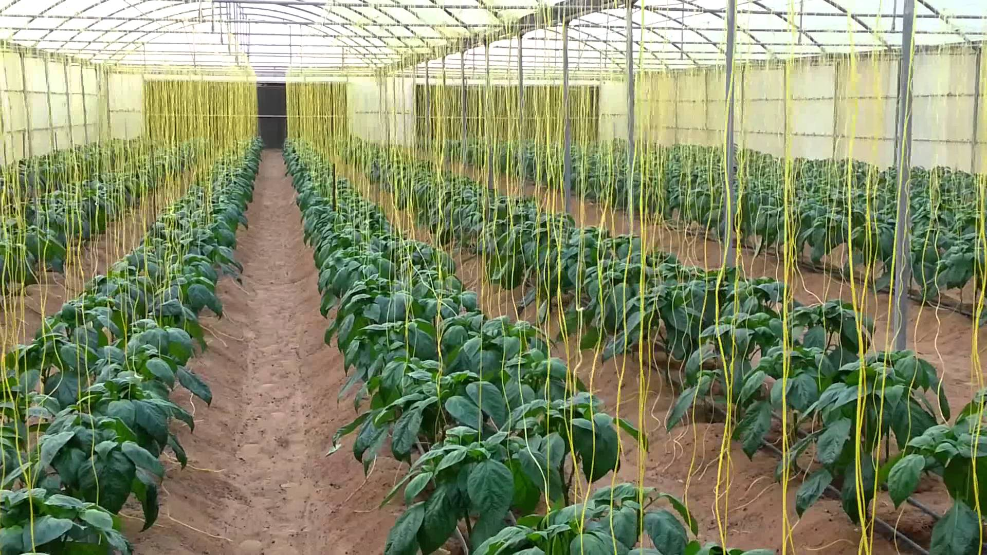
Using Invented Alternative Indirect Air Cooling (IEAC) for Agricultural Greenhouses and Poultry Production in Saudi Arabia
Submitted to:
ESTIDAMA
King Saud University
By:
HUSSEIN, Mohd. Ibrahim , MSc
Researcher. & Agricultural Eng.
Water Resources Development & Management Specialist
UNESCO- Chair in Water, Inventor & Project Developer

Contents
Introduction …………………………………………………….
Description …………………………………………………….
(IEAC ) Vs( EAC )
Direct evaporative cooling ………………………………........
Indirect Evaporative Air Cooling…………………………….....
Expected Results…………………………………………………
Project Implementation and Methodology …………………….
Project Personnel……………………………………………….
Time Frame ………………………………………………………
Budget and resources ………………………………………….

1. Introduction
Saudi Arabia is classified as arid and semi-arid area .according to the geographical location in the desert of Middle East. Where heat and dryness dominate the daily climate through the majority months of the year, the variation of the heat degrees between day and night known as desert climate, all together generate heat stresses for people, Agriculture and animal and restricting some plant varieties to grow and product, This warrant some kind of artificial environment as closed and semi closed greenhouses and poultry and animals closed farms in order to product the daily consumed vegetables and fruits and import the others from nearest countries. Greenhouses using the evaporative cooling partially solved the problems but still direct Evaporative air cooling has its disadvantages such as huge quantity of water consumption and short in conditioning large places due to it short in cooling capacity in dropping down the heat temperature
The Alternative Indirect air-cooling is more efficient and it has benefits in water and energy consumption saving. The majority uses of indirect air cooling is a big units uses for central cooling in buildings and malls because of it efficiency in offering the comfortable heat and humidity, but it never been used in agricultural sector, that there are no models and designs suit the greenhouses

In this proposal, we are trying to deliver an invented designs and smart model that can suit the already existing greenhouses with only change and modification of the backside of the greenhouses and tunnels without changing in the greenhouses specification, this will encourages the farmers to adopt this benefits of the smart design with low cost and adopting the easy maintenance
Witch will provide the means of flexibility and sustainability, with good opportunities for the researches institution to carry more studies in this field
By using some of modern design and invented patents (Ibrahim, 2018), published by WIPO - international which gives some solutions for using new designs of indirect evaporative cooling for greenhouses.

Vision
T continue current researches in greenhouses cultivation by developing practice and methods to meet the challenges including water scarcity and heat conditions in the area through employing of all alternative solution in offering good environment in greenhouses that offer optimum condition for most of vegetables and fruits to grow, and work near with local farmers in understanding their needs and sharing them the solutions to adopt best ways in cultivation with applicable, acceptable and invented modern technologies

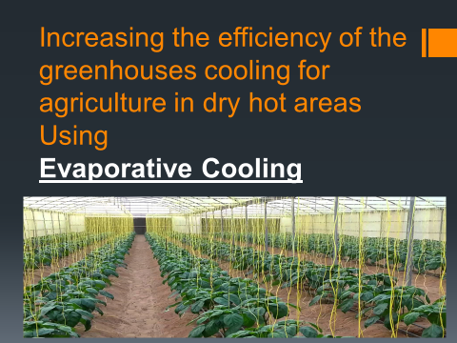
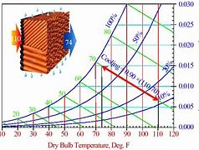

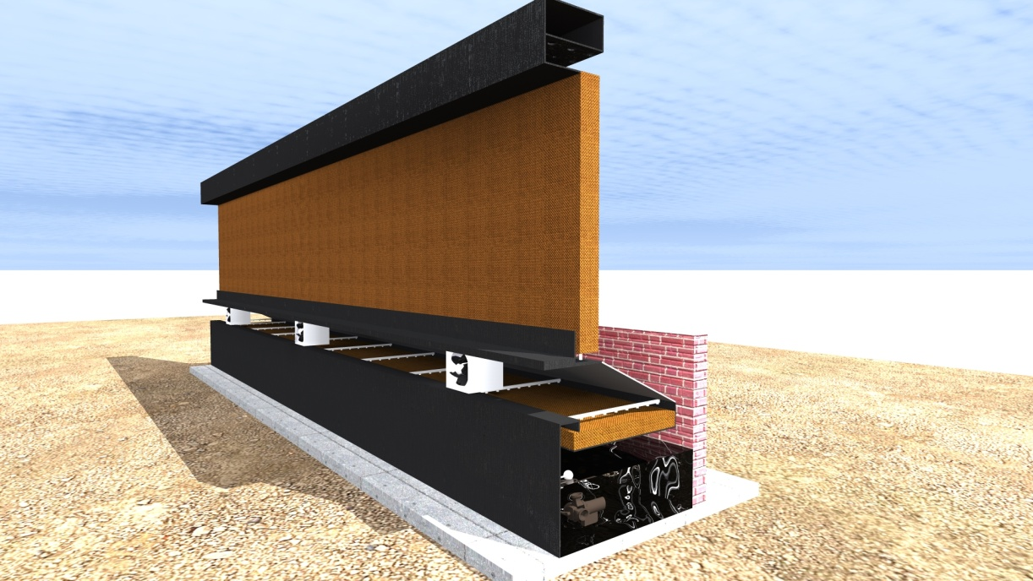
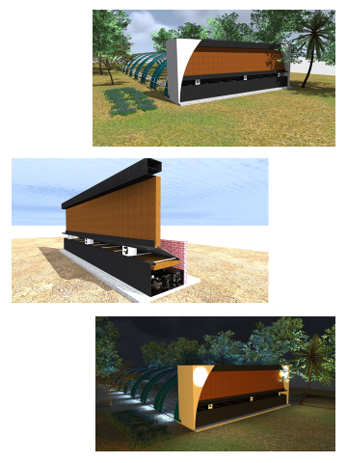

.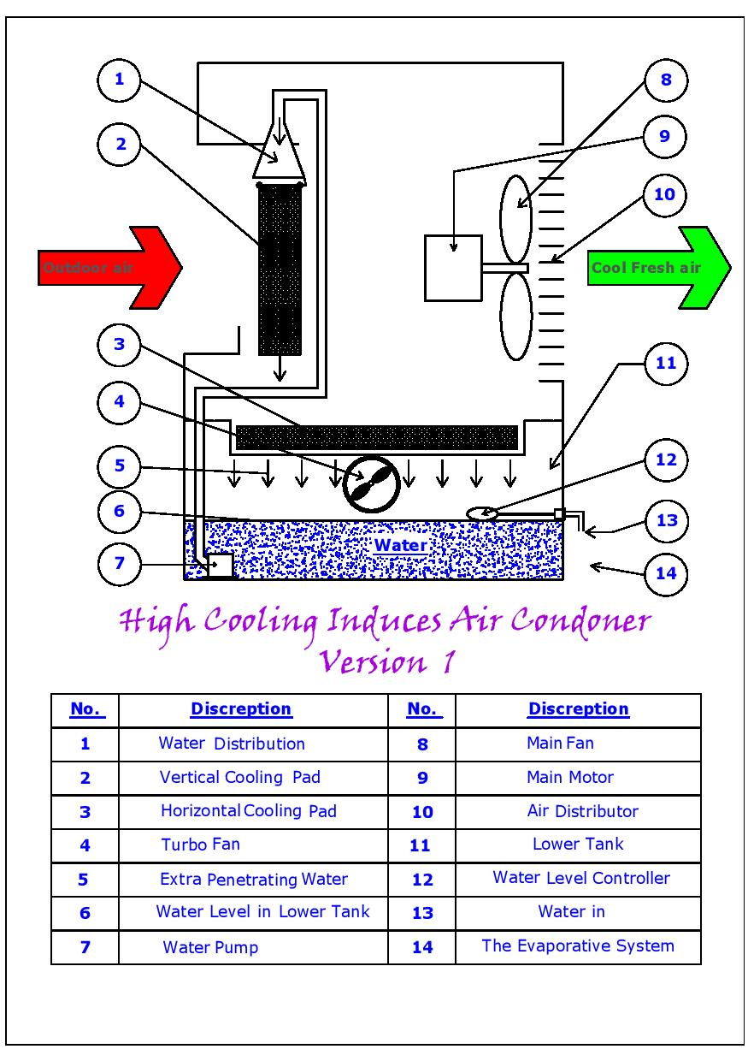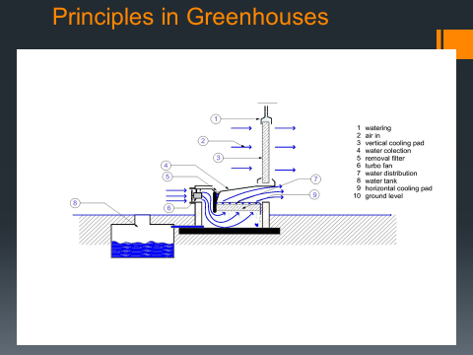

Description

What is Indirect Evaporative Cooling?
How indirect evaporative cooling system works is explained sequentially:
- In one type of System ,Hot outside air is blown over a heat exchanger through which cold water is supplied . This type of heat exchanger features a series of metal tubes through which cold water is supplied and hot air blown over the tubes and fins. As hot air passes over these tubes, its sensible heat is removed. After passing over the tubes, the cool, dry is delivered to living space. It not only lowers down dry bulb temperature but wet bulb temperature as well. Indirect Evaporative cooler find application where low humid but 100% fresh air is needed for cooling.
- The important point is that the hot air is cooled without gaining any extra humidity.
Indirect evaporative cooling provides cool air to interior spaces with less Relative humidity compared to direct evaporative cooling. This, cooling method is more suitable for areas where additional humidity is not desirable. Since indirect evaporative cooling requires two pumps rather than one, it consumes little more electricity than direct evaporative cooling.

In second type of Indirect Evaporative Cooling system -primary warm air flows in enclosed channels .It gives up its heat to water films flowing down the other side of the polymeric plates. A secondary air stream flowing in the direction opposite to the water evaporates water before it is exhausted outside. Thus, in Indirect Evaporative cooler the primary air is cooled without any moisture addition .
Indirect evaporative cooling system to produce cold water and indirect evaporative cooling system to produce cooling air are compared in this paper. From the process transformation, to remove the same quantity of indoor heat, the indirect evaporative air cooler system produces much more cooling energy in which more than a half is wasted to cool fresh air and also more heat transfer area are used. Also the transportation electricity consumption is much higher when using cooling air than using cold water.
C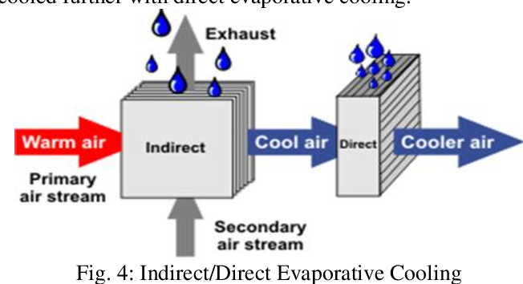 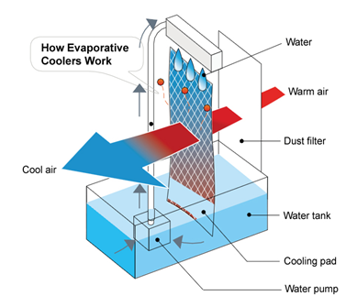
.
Direct Evaporative Cooling
This method utilizes fresh air from outside, which is then brought through ventilation ductwork and met with humidity in a dedicated air handling unit. This airstream with a higher moisture content (relative humidity) achieves an optimal temperature and just the right amount of hydration before being dispersed indoors. That conditioned air is critical as, since a greater amount of existing room air is exhausted, it replaces it and helps to regulate indoor conditions. If the air absorbs more moisture going in due to having lower initial relative humidity, the evaporative cooling effect will be stronger.

Indirect Evaporative Cooling
This is a different approach, forgoing the air exchange process of the direct alternative. Instead, outside air is brough through ventilation to lower indoor temperatures without mixing the two air streams. Fresh outside air is run through the evaporative humidifier and AHU's heat recovery (HR) unit and then exhausted without any mixing, while the return air from the room is run through the HR unit. Using this method, if the air temperature after the evaporative humidifier is cooler than the room temperature, it is possible cool the return air before being re-introduced to the room. This method has the advantage of effectively cooling the airstream without over-humidifying the air, because moisture isn’t added to the supply air and the outside air that is being humidified is exhausted. In that sense, indirect evaporative cooling solutions such . are useful even in seasonal environments or areas where the outside temperature is higher than indoors.

Stating of the Problems
Short in cooling capacity of direct evaporative cooling (DEAC ), and its related disadvantage io offering the optoimum environment in agricultural sector in Saudi Arabia (greenhouses and poultry production ) and the needs of developing these sectors warant researches and studies to find other invenmted solution to encourage farmers to develop their practices and enough supply markets, in addition that this type of air cooling cunsuming large quatities of water and energy

Expected results
- Of replacing direct evaporative air cooling with new invented Indirect evaporative cooling (IEAC).
- Encreasing of cooling capacities
- Humidity controling
- Heat Control
- Energy Saving
- Water Saving
- Delever cooler airby the flow air heat exchanger first
- Increasing Agricultural Production
- Acceptable by farmers
- More ablicable in implemintation and maintinance
- Sautable in arfeas of water scarcity
Project Implimintation plan and Methodology
The Project Is devided to tow Parts
Primary Experements
- Constructing a simulation prototyopes and conducting test to it,takes reads and measurments,ana,lyses data and judge the Idea.

Secondarry Experements
Extend the Experements on real Sizes of numbers of greenhouses
- Connecting sensors to collect data such as dry bulb tempreture, wet bulb tempreture, relative humidity, emnergy consumption and water consumption
- By choosing numbers of already exiting greenhouses by vulinteer farmers and carry the experments to it
- Collecting data,analyses data and get the result
- Evaluation and final reports
Experiments and tests
All intended experiments for prototypes and real size will be conducted by
Intertek multinational testing laboratories company- Riyadh, Authorized by Saudi standard ,metrology and quality organization (SASO).
Partners & Stakeholders
Suggested
1-
2-
3-
4-
Project personals
- Supervisior.
- Project Manager
- High expereionces Lab technitions
- Well trained labours
- Master digree Students
Time Frame:
36 Months – 3 years
Budjet and Sources.
The estimated budget to be estimated

