

COVID-19 Bioimpedance Monitoring Protocol Development Study

Research Study Outline
March 27, 2020
By Shimmer Research, Inc.

Contact:
Geoffrey Gill
President
ggill@shimmersensing.com
+1.617.930.0367

Table of Contents
1. Introduction 4
2. Company Information 4
3. Equipment 5
4. Study Protocols 6
4.1. In-Hospital Arm 6
4.2. Remote Monitoring Study 7
4.3. Timeline 7
5. Partners 7
6. Implementation Preparation 8
7. Appendix 1: Sample Bioimpedance Respiration Signal 9
8. Appendix 2: Sample of References using Bioimpedance to Monitor Fluid in the Lungs 10
Bioimpedance monitoring: better than chest x‐ray for predicting abnormal pulmonary fluid? 10
Transthoracic bioimpedance can measure extravascular lung water in acute lung injury 10
Monitoring lung fluid content in CHF patients under intravenous diuretics treatment using bio-impedance measurements 10
A portable bio-impedance system for monitoring lung resistivity 10
Bioimpedance: a novel method for the determination of extravascular lung water 10
Optimal electrode placement and frequency range selection for the detection of lung water using bioimpedance spectroscopy 11
Bioelectrical impedance spectroscopy as a fluid management system in heart failure 11
Noninvasive estimation of extravascular lung water using bioimpedance 11
On the road to a textile integrated bioimpedance early warning system for lung edema 11
Coffee consumption and total body water homeostasis as measured by fluid balance and bioelectrical impedance analysis 12
[PDF] Evaluation of transthoracic bioelectrical impedance analysis in monitoring lung water during diuresis 12
Monitoring of body fluid in patients with chronic heart failure using Bioimpedance-Spectroscopy 12
Comparison of thoracic electrical bioimpedance and thermodilution for the measurement of cardiac index in patients with severe sepsis 12
Use of bioimpedance spectroscopy to determine extracellular fluid, intracellular fluid, total body water, and fat-free mass 12
The usefulness of bioelectrical impedance analysis in differentiating dyspnea due to decompensated heart failure 13
Monitoring lung resistivity changes in congestive heart failure patients using the bioimpedance technique 13
Bio-impedance apparatus and method 13
Comparing lung ultrasound with bioimpedance spectroscopy for evaluating hydration in peritoneal dialysis patients 13
[HTML] Finding covert fluid: methods for detecting volume overload in children on dialysis 14
Influence of crystalloid and colloid fluid infusion and blood withdrawal on pulmonary bioimpedance in an animal model of mechanical ventilation 14
The use of transthoracic electrical bioimpedance in assessing thoracic fluid status in emergency department patients 14
Sensitivity of a wearable bioimpedance monitor to changes in the thoracic fluid content of heart failure patients 14
Determination of the relation between alterations of total body water and thoracic fluid content during ultrafiltration by bioelectrical impedance analysis 15
The effect of thoracentesis on lung function and transthoracic electrical bioimpedance 15
Bioimpedance analysis versus lung ultrasonography for optimal risk prediction in hemodialysis patients 15
Bioelectrical impedance techniques in medicine part III: impedance imaging third section: medical applications 15
[PDF] … OF A 1 LITER FLUID LOAD ON BODY COMPOSITION MEASURED BY AIR DISPLACEMENT PLETHYSMOGRAPHY AND BIOELECTRICAL IMPEDANCE. 15
Evaluating calf bioimpedance measurements for fluid overload management in a controlled environment 16
Bioelectrical impedance analysis: clinical tool in assessing total body water and thoracic fluid 16
Bioelectrical impedance analysis—part II: utilization in clinical practice 16

Introduction
Bioimpedance, specifically across the lungs, has long been studied in Chronic Heart Failure (CHF) and Acute Respiratory Distress Syndrome (ARDS). This measurement can provide a number of useful indicators of respiration rate, respiration volume, and fluid in the lungs. A short sampling of academic references is listed in the appendix. Because COVID-19 attacks the lungs, these measurements can provide clear indications of the progression of the disease. This information can be used in many ways, potentially including:
- Monitoring patients remotely at home to determine, if and when, they will need to be admitted to the hospital
- Monitoring patients in a hospital to determine when they need more aggressive treatment (e.g., ventilators)
- Enabling the earlier release of non-acute patients because of the ability to monitor at home
- Adjusting the treatment depending on the rate of progression of disease
Shimmer has an off the shelf product (the Shimmer3) that can be used to monitor bioimpedance. Because COVID-19 is a new disease, baseline information needs to be obtained to develop thresholds and protocols for this management. This document outlines two research projects to establish these thresholds and protocols. This outline is not a full study design but is designed to obtain preliminary commitments from sponsors. The full study design will be completed with input from the sponsor and appropriate partners.
This research project is just the beginning. The results will be incorporated into a protocol to use this information in clinical practice. In parallel, Shimmer will be preparing to support a wide deployment of the devices, including integrating the device into EHR or other clinical management systems and preparing to ramp up production to the required levels.

Company Information
This project will be managed by Shimmer Research, Inc. (Shimmer US), located in Cambridge, MA. Shimmer US is the U.S. member of a group of affiliated companies owned by RealHoldCo DAC of Dublin, Ireland. Other relevant members of the group include Shimmer Research, Ltd (an ISO 13485:2016 medical device manufacturer which is the headquarters for the Shimmer products) and Realtime Technologies, Ltd (an ISO 13485:2016 certified contract manufacturing company which manufactures Shimmer products, in addition to many others). In addition, Realta Solutions SDN BHD is a subcontractor in Malaysia that is 100% dedicated to Shimmer development work. In this proposal, these entities are referred to collectively as “Shimmer.”

Equipment
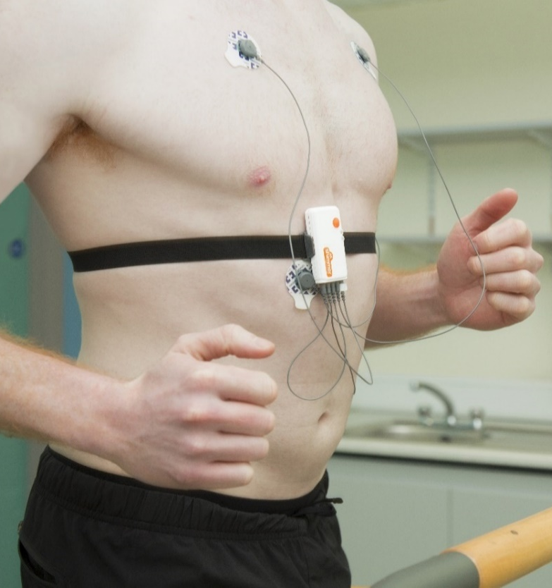
For this study, Shimmer proposes using its Shimmer3 ECG/Bioimpedance sensor. This sensor was introduced in 2013 and has been used successfully in literally thousands of studies in over 70 countries. It is CE marked for safety but is not a registered medical device. However, Shimmer is a registered ISO 13485:2016 medical device manufacturer and will seek regulatory approval as appropriate.
Figure 1: Shimmer3 ECG/Bioimpedance Sensor
Figure 1 shows a photo of the sensor on a person. Figure 2 shows the recommended placement of electrodes when used in the bioimpedance mode. Only three electrodes are required for bioimpedance measurement. The LL and Vx electrodes are used to capture ECG signals. Because these electrodes are in non-standard locations for ECG and the bioimpedance signals generate high frequency noise that must be filtered out, the shape of the ECG wave may be affected somewhat. However, the signal is more than adequate to capture accurate heart rate. Appendix 1 shows some data from simultaneous capture of bioimpedance and ECG, before and after filtering.
Data can be collected at a variety of rates, from 1Hz to over 1kHz. We recommend a 200Hz data rate for bioimpedance. At 200Hz, the sensor has onboard storage to last 29 days. For the remote monitoring study, all data will be stored on the device and uploaded upon return to the site. The Shimmer3 ECG system uses any standard ECG electrode to capture the ECG and/or bioimpedance signal. We will work with the Sites to select the most appropriate for this study.
In addition to ECG and bioimpedance data, the sensor can simultaneously collect 9 degree of freedom IMU data (3-axis accelerometer, 3-axis gyro, and 3-axis magnetometer).
The battery will provide the needed energy to run the equipment for 2+ days without recharging in the local data storage mode. In the streaming mode, the battery life is 8+ hours.
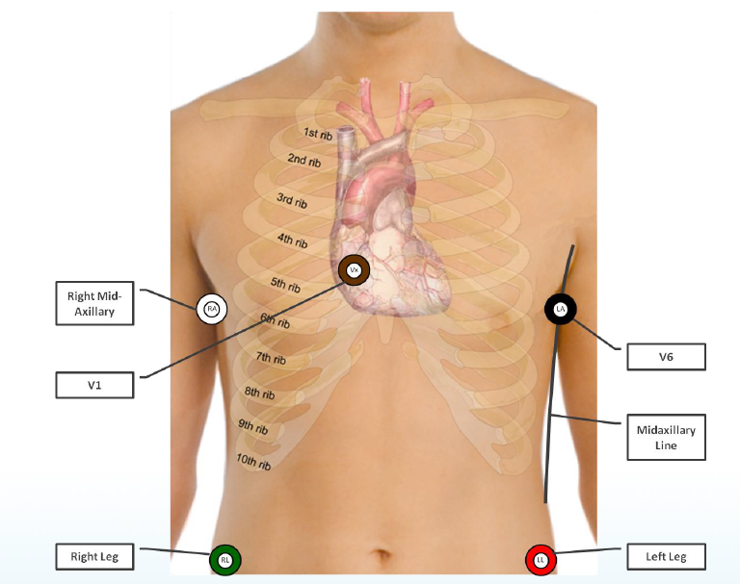
Figure 2: Recommended Bioimpedance Electrode Placement

Protocol Development Study
There are two arms to this study. One is focused on monitoring critically ill COVID-19 patients in a hospital setting and the other will look at tracking non-acute COVID-19 patients following their progression to determine thresholds to suggest admittance to a hospital and or other interventions. Each arm can be done independently.

In-Hospital Arm
This arm will look at the more critically ill patient population to track and understand disease progression and determine thresholds for increasingly aggressive interventions. Participants will be recruited upon admission to the hospital for COVID-19 related illness. They will be given a Shimmer3 sensor to be worn at least 16 hours per day. Data will be streamed via Bluetooth to a local computer for display displayed and also logged on the sensor itself. The sensor will be worn until the participant is released from the hospital.
We believe that a reasonable sample size for this study will be 50 patients, although we are open to expanding that number.

Remote Monitoring Study
This arm will look at less ill COVID-19 positive participants and track their progression as they are in quarantine to understand disease progression and determine thresholds for hospital admittances and other interventions. Participants will be recruited upon a positive test for COVID-19. They will be given a Shimmer3 sensor to be worn remotely for at least 16 hours per day until they are declared free of the virus (for up to 21 days). Data will be logged on the sensor itself. At the end of the monitoring period, the participant will return the sensor. At this point, the participant should be free from the virus and not communicable so it should be possible return it via a postage paid package. If, on discussions with medical personnel, it becomes apparent that this procedure is risky, it will need to be picked up by study personnel. If the participant is admitted to the hospital, they will be added to the In-Hospital arm of the study and wear the sensor until the participant is released from the hospital.
We believe that a reasonable sample size for this study will be 250 patients, although we are open to adjusting that number.

Timeline
The monitoring phase is likely to last no more than 2-3 weeks for each participant and there is a high prevalence of COVID-19 currently. We believe that patients will be highly motivated to participate in this research and we anticipate recruitment could be done in as little as a week. We will be monitoring data during the collection phase and anticipate developing draft protocols during the course of the study. The signal provided by bioimpedance is strong and interpretation relatively straightforward. As a result, we believe the clinical protocol recommendations could be completed within one to two weeks of the end of data collection. Thus, the entire program could likely be completed in ~45 days.

Partners
To complete this project as fast as possible, Shimmer will rely on partners to do much of the work. The partners will be in three general categories:
- Analysis – Shimmer has worked with a number of partners to perform analysis on this type of data. The selection of partners will depend on input from the sponsor, but Healthmode, ERT, Vivosense, and Clearsky have appropriate capabilities and Shimmer has long relationships with them.
- Research sites – Shimmer has identified and entered into discussions with a number of potential research sites. Based on these discussions, it will not be difficult to find sites. In fact, a number of the sites are in the process of starting studies that this study could be incorporated into, greatly reducing cost. The selection will be determined by the timing and the desired geographic location of the sponsor.
- Clinical Research Organization – As with sites, CROs have indicated interest and the slowdown in the existing pipeline of clinical trials due to the isolation requirements has freed up capacity. The selection will be determined by the timing and the desired geographic location of the sponsor.

Implementation Preparation
The goal of this research is to develop a clinical protocol to help manage the current crisis. To deploy this system widely, two other pieces need to be in place.
- Availability of hardware – the Shimmer3 is a mature platform, but wide deployment will require ramping up volume significantly. Fortunately, Shimmer’s parent is a contract electronics manufacturer and has committed to providing whatever capacity is needed for this product. The limitation will be on the supply chain. Shimmer has assessed its supply chain and estimates that it can produce an additional 2000 units immediately, 10,000 units in the second month, and up to 50,000 units in future months. Meeting these volume levels will require purchase commitments with deposits, 1-2 months in advance.
- Integration into EHR and/or other Patient Management Systems – Shimmer has existing APIs to enable third parties to easily capture Shimmer data. Once the data is in their systems, the protocols can be encoded, and patient managed through existing system capabilities. Most systems have developed procedures to make such integrations relatively easy and Shimmer’s experienced development team will support these partners in their efforts.
Shimmer will be working with its supply chain and partners in parallel with the research study to ensure that these critical pieces are in place shortly after the completion of the research study.

Appendix 1: Sample ECG/Bioimpedance Respiration Signal
Before and after filtering.
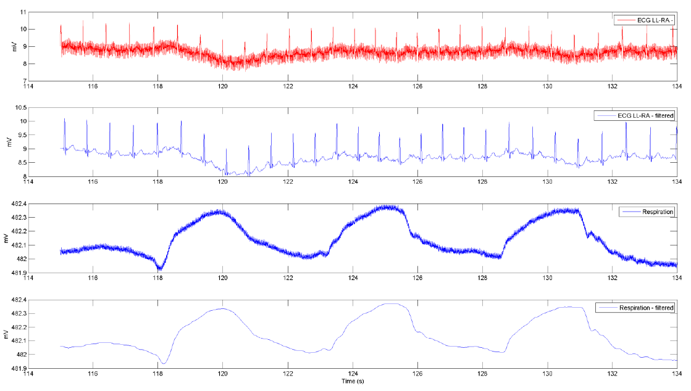

Appendix 2: Sample of References using Bioimpedance to Monitor Fluid in the Lungs

Bioimpedance monitoring: better than chest x‐ray for predicting abnormal pulmonary fluid?
WF Peacock IV, N M. Albert, R D. White… - Congestive Heart …, 2000 - Wiley Online Library
… Measuring the average thoracic resistance provides estimates of total thoracic fluid content …
Renaissance Technology, Inc., IQ® monitor was used to measure thoracic impedance … Noninvasive
Assessment of Lung Fluid Volume and Invasively Measured Cardiac Hemodynamics …
Cited by 55 Related articles All 3 versions

Transthoracic bioimpedance can measure extravascular lung water in acute lung injury
DM Nierman, DI Eisen, ED Fein, E Hannon… - Journal of Surgical …, 1996 - Elsevier
… the difficulty in avoiding the heart and major intratho- racic blood vessels so as to only measure
the lung … thoracic impedance (Z) was measured … Admittedly this point re- mains inexact. Although
we believe we are measuring In a management approach to acute lung injury that …
Cited by 42 Related articles All 8 versions

Monitoring lung fluid content in CHF patients under intravenous diuretics treatment using bio-impedance measurements
D Freimark, M Arad, R Sokolover… - … measurement, 2007 - iopscience.iop.org
A pulmonary edema monitoring system (PulmoTrace™, CardioInspect, Tel-Aviv University,
Israel) was evaluated for tracking lung resistivity during diuretics treatment in congestive
heart failure (CHF) patients. The system incorporates a bio-impedance measurement …
Cited by 27 Related articles All 4 versions
[PDF] academia.edu

A portable bio-impedance system for monitoring lung resistivity
S Zlochiver, M Arad, MM Radai, D Barak-Shinar… - Medical engineering & …, 2007 - Elsevier
… used a 16-electrode EIT system to measure pulmonary edema induced by injection of oleic acid …
system did not come in expense for the dynamic range of the measured lung resistivities … most
prominently a prolongation of the QT interval [2], and therefore measuring and tracking …
Cited by 64 Related articles All 9 versions

Bioimpedance: a novel method for the determination of extravascular lung water
JL Zellner, FG Spinale, FA Crawford - Journal of Surgical Research, 1990 - Elsevier
… However, measuring the contribution of these and other determinants to EVLW may be
cumbersome and … Therefore, stroke volume using bioimpedance was not measured in this study …
Further refinements in this method may provide a means to easily measure serial changes in …
Cited by 47 Related articles All 7 versions
[PDF] rwth-aachen.de

Optimal electrode placement and frequency range selection for the detection of lung water using bioimpedance spectroscopy
L Beckmann, D van Riesen… - 2007 29th Annual …, 2007 - ieeexplore.ieee.org
… The values of the Cole-Cole model Re, Ri and Cm can be determined by measuring the body …
can be explained as follows: Re is mainly dependent on small frequencies which were measured
in every … Thus, it is recommended to measure up to a frequency of 1 MHz to keep the …
Cited by 55 Related articles All 11 versions

Bioelectrical impedance spectroscopy as a fluid management system in heart failure
S Weyer, MD Zink, T Wartzek, L Leicht… - … measurement, 2014 - iopscience.iop.org
… Since this wavelength was much higher than the measuring volume, the low frequency
electroquasistatic … of finding the smallest, most critical feature set, it is useful to measure the relative …
The simulation and the measured data show a clear extracellular impedance shift to lower …
Cited by 36 Related articles All 7 versions

Noninvasive estimation of extravascular lung water using bioimpedance
FG Spinale, HD Reines, MC Cook… - Journal of Surgical …, 1989 - Elsevier
… EVLW was measured using the double dilution method by injection of an iced mixture of 5 … In
addition to measuring cardiac output via the aortic thermistor, thermodilution cardiac output was …
electrodes were used to apply a low amperage signal and measure thoracic impedance …
Cited by 49 Related articles All 6 versions
[PDF] researchgate.net

On the road to a textile integrated bioimpedance early warning system for lung edema
T Schlebusch, L Röthlingshöfer, S Kim… - … Conference on Body …, 2010 - ieeexplore.ieee.org
… Unfortunately, the AD5933 is intended for loudspeaker impedance measurements instead of
bioimpedance measure- ments … 8. Electrode measuring system [17] … The contact impedance is
measured using an Agilent E4980A precision LCR meter in a two electrode measurement …
Cited by 29 Related articles All 7 versions
[PDF] researchgate.net

Coffee consumption and total body water homeostasis as measured by fluid balance and bioelectrical impedance analysis
M Neuhäuser-Berthold, S Beine, SC Verwied… - Annals of nutrition and …, 1997 - karger.com
… Urine samples were collected before each measurement of BIA and BW for the analysis of … Details
on the timing of sampling and measurements throughout the study period are given in … 3763 3,956 ±
4613 -6Ó2 + 3253 1 Fluid intake comprised the exactly measured amount of …
Cited by 90 Related articles All 8 versions
[PDF] mikropolis.pl

[PDF] Evaluation of transthoracic bioelectrical impedance analysis in monitoring lung water during diuresis
DM Nierman, JI Mechanick - Applied Cardiopulmonary …, 1998 - mikropolis.pl
… the best chance of achieving a uniform current distribution within the potential-measuring
electrodes and … body water and body weight, a method with which to directly measure lung water
would … In addition, changes in body weight may not agree with measured fluid balance [21 …
Cited by 17 Related articles All 2 versions

Monitoring of body fluid in patients with chronic heart failure using Bioimpedance-Spectroscopy
L Beckmann, A Cordes, E Saygili, A Schmeink… - World Congress on …, 2009 - Springer
… 8]. The values of the electrical model Re, Ri and Cm can be determined by measuring the body …
body and a second pair to measure the resulting voltage V. Knowing I and V the body … data for
the monitoring of the body water content during the study, we measured the body …
Cited by 16 Related articles All 4 versions
[PDF] sciencedirect.com

Comparison of thoracic electrical bioimpedance and thermodilution for the measurement of cardiac index in patients with severe sepsis
JD Young, P McQuillan - British journal of anaesthesia, 1993 - Elsevier
… G, Koch W. Comparison of impedance cardiography and echocardiography for measure- ment
of … Edmunds AT, Godfrey S, Tooley M. Cardiac output measured by transthoracic impedance …
Comparison of two impedance cardiographic techniques for measuring cardiac output in …
Cited by 78 Related articles All 11 versions

Use of bioimpedance spectroscopy to determine extracellular fluid, intracellular fluid, total body water, and fat-free mass
MD Van Loan, P Withers, J Matthie… - Human body composition, 1993 - Springer
… It is theoretically possible to measure the extracellular fluid (ECF) and intracellular fluid (ICF … R
and X were measured at 25 logarithmically spaced frequencies from 1 KHz to 1.35 … from fluid
spaces to density: analysis of methods, in: ''Techniques for Measuring Body Composition …
Cited by 158 Related articles All 4 versions

The usefulness of bioelectrical impedance analysis in differentiating dyspnea due to decompensated heart failure
G Parrinello, S Paterna, P Di Pasquale, D Torres… - Journal of cardiac …, 2008 - Elsevier
… sensor electrodes (white circles) and the source electrodes (black triangles) are placed while
measuring bioelectrical impedance … but does not appear to be a precise indicator of measured
blood volume … 30 BIA is a technique to measure the impedance or opposition to the flow …
Cited by 93 Related articles All 7 versions
[PDF] wiley.comFull View

Monitoring lung resistivity changes in congestive heart failure patients using the bioimpedance technique
S Zlochiver, MM Radai, D Barak‐Shinar… - Congestive Heart …, 2005 - Wiley Online Library
… electrical resistivity of the left and right lungs using a degenerated EIT measuring scheme … 18
eg, InSync Sentry (Medtronic, Inc., Minneapolis, MN), where lung impedance is measured using
electric … Not only is this kind of measurement invasive, but it can only provide estimation …
Cited by 16 Related articles All 6 versions
[PDF] googleapis.com

Bio-impedance apparatus and method
S Arad - US Patent 7,907,998, 2011 - Google Patents
… As used herein, “making impedance measurements” includes measuring any quantities, such
as voltage … substantially contribute to total current between electrodes used to measure impedance,
since … edema, and the lung impedances as well as the measured impedances are …
Cited by 60 Related articles All 4 versions

Comparing lung ultrasound with bioimpedance spectroscopy for evaluating hydration in peritoneal dialysis patients
K Paudel, T Kausik, A Visser, C Ramballi, SL Fan - Nephrology, 2015 - Wiley Online Library
… Bio‐Rad, Hercules, CA, USA; normal value considered to be <2000 ng/L, measuring range 5 …
N‐terminal pro–brain natriuretic peptide (NT‐proBNP) measured in ng/L, OH measured in L … In
the absence of direct and dilutional estimation methods to measure total body water (by …
Cited by 23 Related articles All 6 versions
[HTML] springer.com

[HTML] Finding covert fluid: methods for detecting volume overload in children on dialysis
M Allinovi, MA Saleem, O Burgess, C Armstrong… - Pediatric …, 2016 - Springer
… Dissociation between SBP elevation and measured parameters of fluid overload … The gold standard
measure of fluid overload, namely deuterium dioxide dilution, was not used … Haycock GB, Schwartz
GJ, Wisotsky DH (1978) Geometric method for measuring body surface area: a …
Cited by 16 Related articles All 9 versions
[PDF] researchgate.net

Influence of crystalloid and colloid fluid infusion and blood withdrawal on pulmonary bioimpedance in an animal model of mechanical ventilation
M Bodenstein, H Wang, S Boehme… - … measurement, 2012 - iopscience.iop.org
… Inspiratory pressure (ΔP = P max – PEEP) and tidal volume (V T ) were measured by the … The
differences between the different measurement points in the no-fluid group were partially … The
difference between both groups at baseline measurements was 2.6 ± 3.7 (CI: −8.0 to 4.79 …
Cited by 12 Related articles All 9 versions

The use of transthoracic electrical bioimpedance in assessing thoracic fluid status in emergency department patients
CE Saunders - The American journal of emergency medicine, 1988 - Elsevier
… This study demonstrates that Z measurement and real-time monitorlng can be a useful and non-
invasive means of assessing TF status in ED … THORACIC FLUID STATUS FIGURE 1. Measured
Z values for thoracic fluid status in clinical subgroups … measure of thoracic fluid volume …
Cited by 63 Related articles All 7 versions
onlinelibrary.wiley.com
[PDF] psu.edu

Sensitivity of a wearable bioimpedance monitor to changes in the thoracic fluid content of heart failure patients
S Dovancescu, A Torabi, T Mabote… - … in Cardiology 2013, 2013 - ieeexplore.ieee.org
… 1) The parameters of the Cole model (RE' R" CM and a) can be estimated by measuring the body …
However, values measured within one session, varied within a narrow range around the session
mean, Rl, as shown … medication omlSSlOn based on absolute measurement values …
Cited by 12 Related articles All 11 versions

Determination of the relation between alterations of total body water and thoracic fluid content during ultrafiltration by bioelectrical impedance analysis
A Vonk Noordegraaf, BJM Van der Meer… - Nephrology Dialysis …, 1995 - academic.oup.com
… Identifying body fluid distribution by measuring electrical imped- ance … Assessment of post-dialysis
dry weight: an application of the conductivity measurement method … Page 4. Fluid shifts during
ultrafiltration measured by impedance analysis electrical impedance in patients after …
Cited by 18 Related articles All 8 versions
[PDF] sciencedirect.com

The effect of thoracentesis on lung function and transthoracic electrical bioimpedance
B Zerahn, BV Jensen, F Olsen, JR Petersen… - Respiratory …, 1999 - Elsevier
… Guidelines for the measurement of respiratory func- tion … Transthoracic electrical impedance;
quantitative evaluation of a non- invasive measure of thoracic fluid volume … Petersen JR, Jensen
BV, Drabaek H, Viskum K, Mehlsen J. Electrical impedance measured changes in …
Cited by 14 Related articles All 9 versions
[PDF] academia.edu

Bioimpedance analysis versus lung ultrasonography for optimal risk prediction in hemodialysis patients
D Siriopol, L Voroneanu, S Hogas, M Apetrii… - The international journal …, 2016 - Springer
… Recent studies indicate that the fluid overload indices derived from bioimpedance measurement
are independent … of NYHA class, diabetes, hs-CRP levels or LVMI), using three measurements
of performance … MJ, D'Agostino RB (2004) Overall C as a measure of discrimination in …
Cited by 31 Related articles All 10 versions

Bioelectrical impedance techniques in medicine part III: impedance imaging third section: medical applications
JP Morucci, B Rigaud - Critical Reviews™ in Biomedical …, 1996 - dl.begellhouse.com
… C: to –3% °C", thus questioning the feasibility of EIT as a temperature-measuring method … et al.”
have shown that it was possible, using EIT, to detect and measure changes in … Two EIT indices
of pharyngeal transit time were repeatedly measured in 20 normal adults." The time …
Cited by 134 Related articles All 4 versions
[PDF] asep.org

[PDF] … OF A 1 LITER FLUID LOAD ON BODY COMPOSITION MEASURED BY AIR DISPLACEMENT PLETHYSMOGRAPHY AND BIOELECTRICAL IMPEDANCE.
CJ Heiss, N Gara, D Novotny, H Heberle… - Journal of Exercise …, 2009 - asep.org
… Measure Time 0 Time 1 Mean±SD P-value … Effect of changes of water and electrolytes on
the validity of conventional methods of measuring fat-free mass … A small food or fluid load
has no effect on body composition measured by 3 different methods …
Cited by 42 Related articles All 4 versions
[PDF] iop.org

Evaluating calf bioimpedance measurements for fluid overload management in a controlled environment
M Delano, C Sodini - Physiological measurement, 2018 - iopscience.iop.org
… visits on a regular (eg monthly) basis, where the physician will measure the patient's … Pressure
monitors have the advantage of measuring heart filling pressures directly or indirectly, which … to
estimate fluid status based on the electrical properties of the measured tissue (Grimnes …
Cited by 9 Related articles All 4 versions

Bioelectrical impedance analysis: clinical tool in assessing total body water and thoracic fluid
P De Vries, AV Noordegraaf… - … journal of artificial …, 1995 - journals.sagepub.com
… That rapid changes in fluid volumes can also be measured adequately was shown in a study
in healthy … Changes in blood parameters during hemodialysis as determined by conductivity
measure- ments … Indentifying body fluid distribution by measuring electrical impedance …
Cited by 7 Related articles All 5 versions
[PDF] academia.edu

Bioelectrical impedance analysis—part II: utilization in clinical practice
UG Kyle, I Bosaeus, AD De Lorenzo, P Deurenberg… - Clinical nutrition, 2004 - Elsevier
… Identify type of signal measured (ie impedance or R or PhA or Xc) … Cardiac insufficiency, Edema
interferes with measurement, Measure patient in stable condition … IV/Electrolyte infusions,
Peripheral edema interferes with measurement, Measurements are invalid if patient is …
Cited by 1611 Related articles All 19 versions



