H₂S Dry Scrubber – Odor Control

Technical Description of the Product

- The absorbent combines premium quality activated carbon together with a blend of catalytically active inorganic phases
- Mechanism: H₂S is catalytically oxidized to sulfur (S) in the active sites on metal oxides. Next, sulfur migrates and builds up in the micropores of the activated carbon phase. Thus, the metal oxides are available again to oxidize new H₂S molecules
- H₂S is not converted to sulfuric acid which may lead to equipment corrosion problems

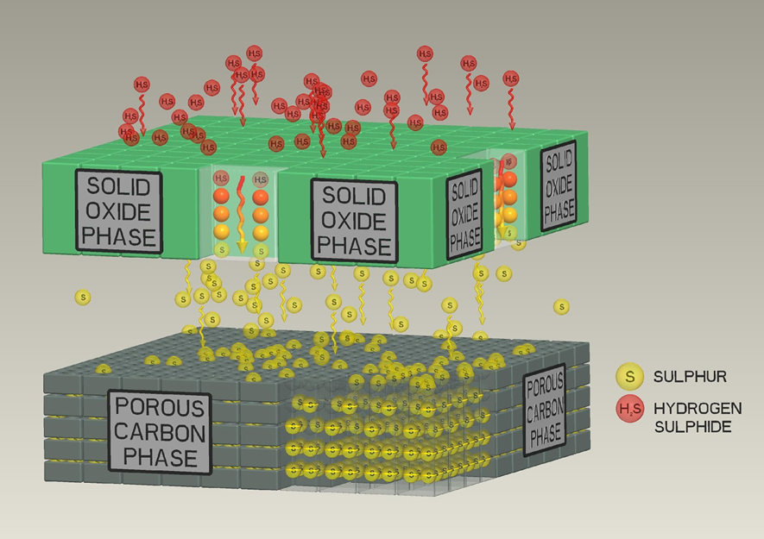

Added Benefits

- High H₂S removal efficiency (> 99%) upon variable inlet conditions
- Sulfur loading is not affected in the presence of high CO₂ levels
- Does not require frequent change outs or time consuming regenerating processes
- Safe to handle and use
- The high ignition temperature (420 ºC) minimizes the risk of bed fire
- Low pressure drop, due to the nominal pellet diameter (4 mm)
- Does not need to undergo long term conditioning prior to being put into operation

Applications

Any use that requires control of H₂S gas, such as:

- Wastewater treatment plants
- Pumping stations
- Wet wells
- Lift stations
- Sludge holding tanks
- Refineries
- Pulp and paper mills
- Composting

Benchmark

See following chart to appraise how the absorbent compares to counterpart products from other manufacturers across the globe

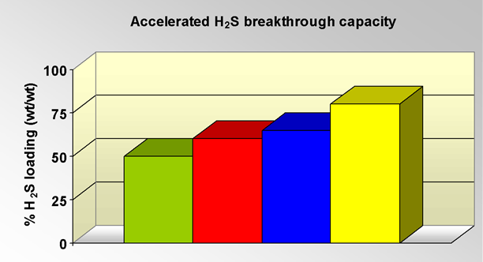

Purafil Odorcarb Ultra
US Filter Midas OCM
Jacobi Addsorb Sulfox
New Product

Testing
The absorbent has been tested several times (>100) against H₂S absorption capacity, following the directions of ASTM 6646-03, which account for:
- Contact time: 4,8 seconds
- Inlet H₂S Concentration: 10.000 ppmv (= 1% v/v)
- 80% relative humidity inlet gas
- Balance gas: pre-filtered air from the environment
- Breakthrough measured at outlet H₂S concentration of 50 ppm (= 99.5% efficiency)
Also, a TGA analysis proves that elemental sulfur is formed.

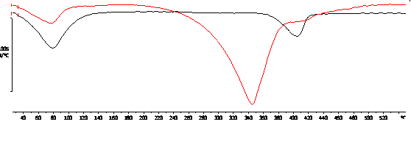
Fresh product
Spent product

Specifications

SPECIFICATIONS
H₂S removal capacity | 0.8 g H₂S/ g media, min.
Nominal pellet diameter | 4 mm (other diameters possible)
Moisture content | 25% max.
Bulk density | 460 ± 20 g/cm³
Loss on attrition | 4.5% max.
Ignition temperature | 420 ºC (UL₂)
pH of spent carbon | Neutral

Field Study
This product has been successfully tested in several countries and applications.
Among them, one of the largest WWTP of Spain (255.000 m³/day). The product was tested after experiencing fire hazards and low bed life with traditional alkali impregnated activated carbon.


